**SQL ASSIGNMENT SET 3**

**Q101) Write an SQL query to show the second most recent activity of each user. If the user only has one activity, return that one. A user cannot perform more than one activity at the same time.**

**Return the result table in any order. The query result format is in the following example.**

Sol)At first create an empty table named ‘UserActivity’ and then insert records in it using multi insert statement.

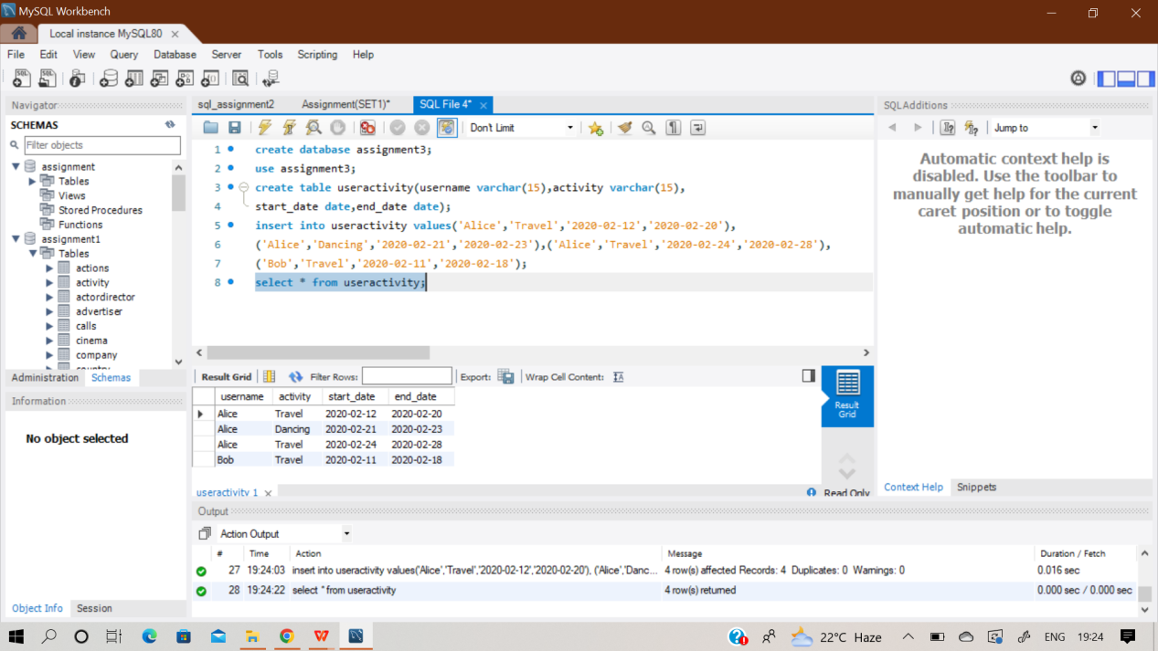

**Select username,activity,start_date,end_date from**

**(select *,**

**rank() over(partition by username order by start_date desc) as 'rnk',**

**count(activity) over(partition by username) as 'count'**

**from useractivity) as u**

**where (count <> 1 and rnk = 2) or (count = 1 and rnk = 1);**

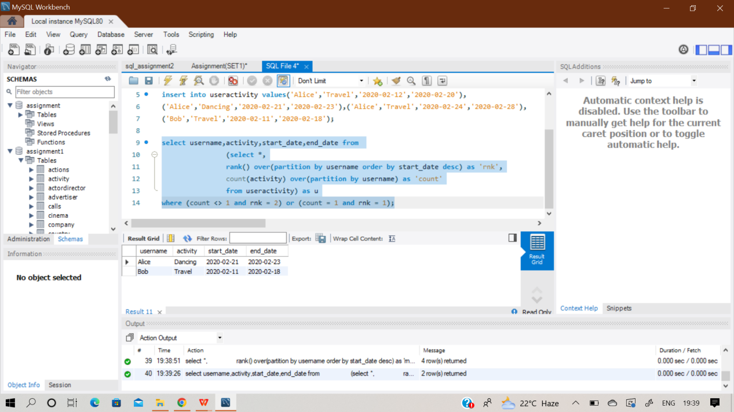

**Q102) SAME QUESTION AS Q101**

**Q103) Query the Name of any student in STUDENTS who scored higher than 75 Marks. Order your output by the last three characters of each name. If two or more students both have names ending in the same last three characters (i.e.: Bobby, Robby, etc.), secondary sort them by ascending order.**

Sol)At first create an empty table named ‘students’ and then insert records in it using multi insert statement.

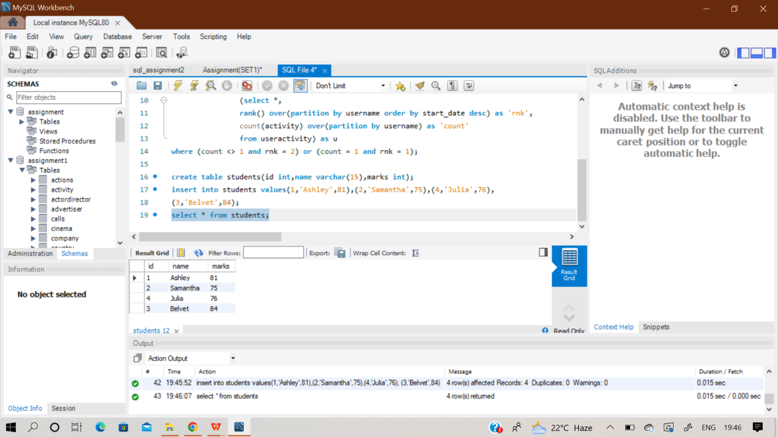

**select name from students**

**where marks>75**

**order by SUBSTR(name, -3), id asc;**

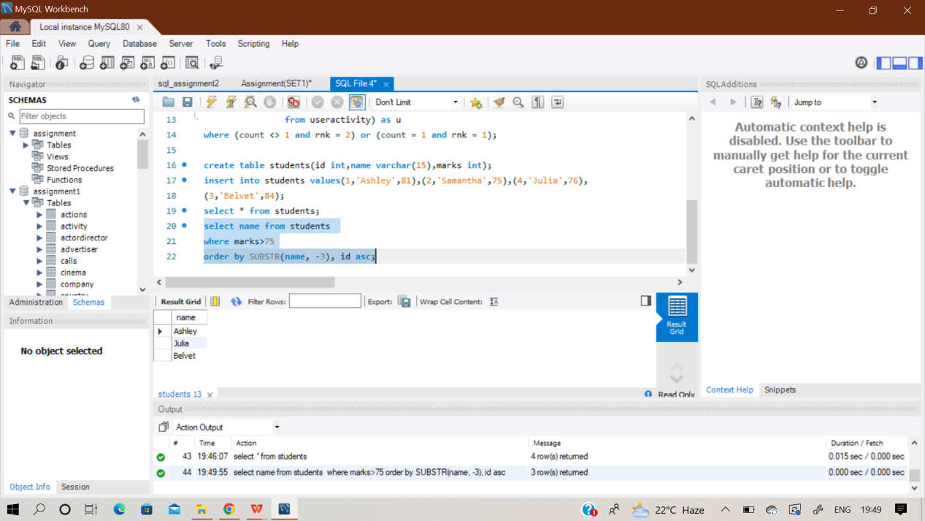

**Q104) SAME QUESTION AS Q82**

**Q105) SAME QUESTION AS Q83**

**Q106) SAME QUESTION AS Q84**

**Q107) Samantha was tasked with calculating the average monthly salaries for all employees in the EMPLOYEES table, but did not realize her keyboard's 0 key was broken until after completing the**

**calculation. She wants your help finding the difference between her miscalculation (using salaries with any zeros removed), and the actual average salary.**

**Write a query calculating the amount of error (i.e.: actual - miscalculated average monthly salaries),**

**and round it up to the next integer.**

Sol)At first create an empty table named ‘employees’ and then insert records in it using multi insert statement.

**select ceil(avg(salary)-avg(replace(salary,'0','')))**

**From employees**

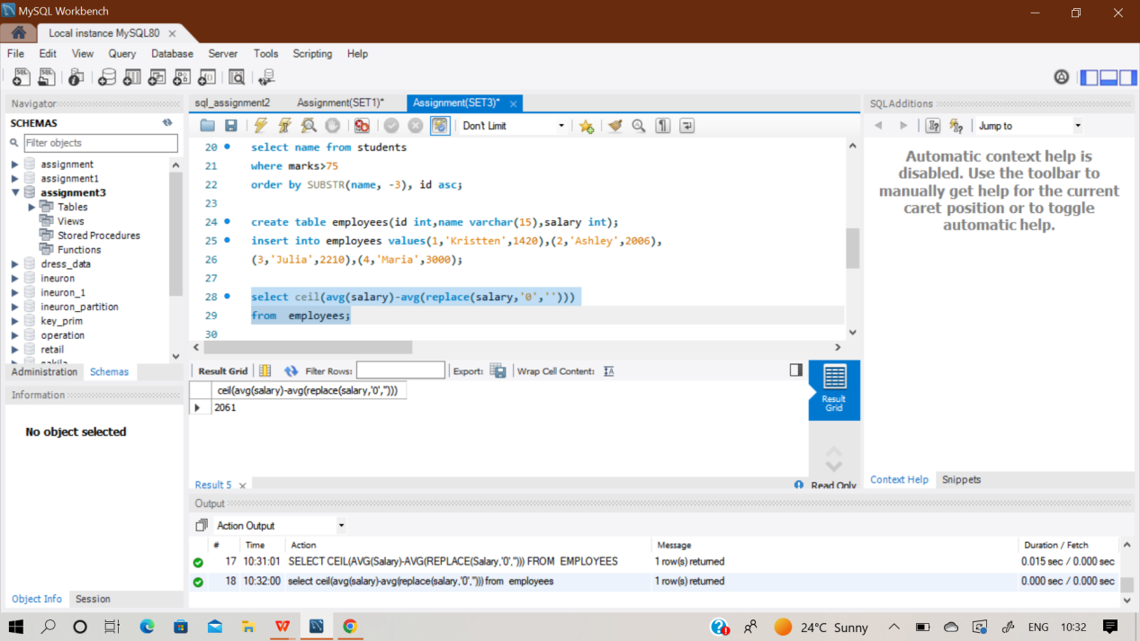

**Q108) Write a query to find the maximum total earnings for all employees as well as the total number of employees who have maximum total earnings. Then print these values as 2 space-separated integers.**

Sol)At first create an empty table named ‘employee’ and then insert records in it using multi insert statement.

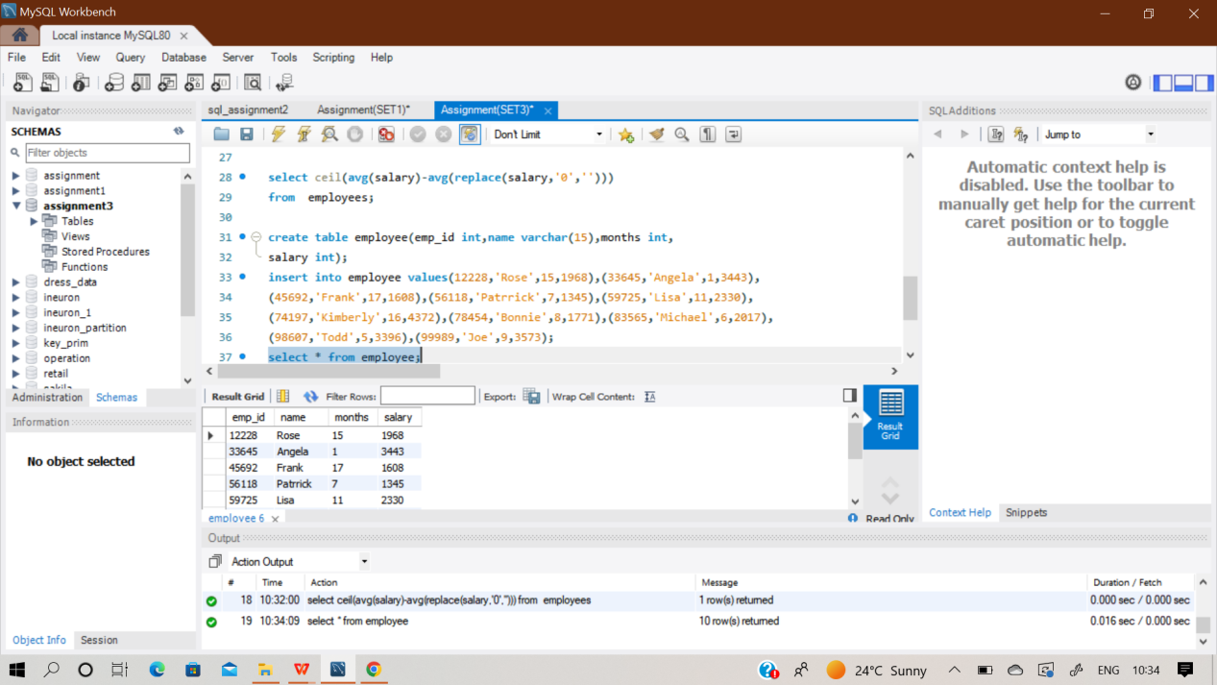

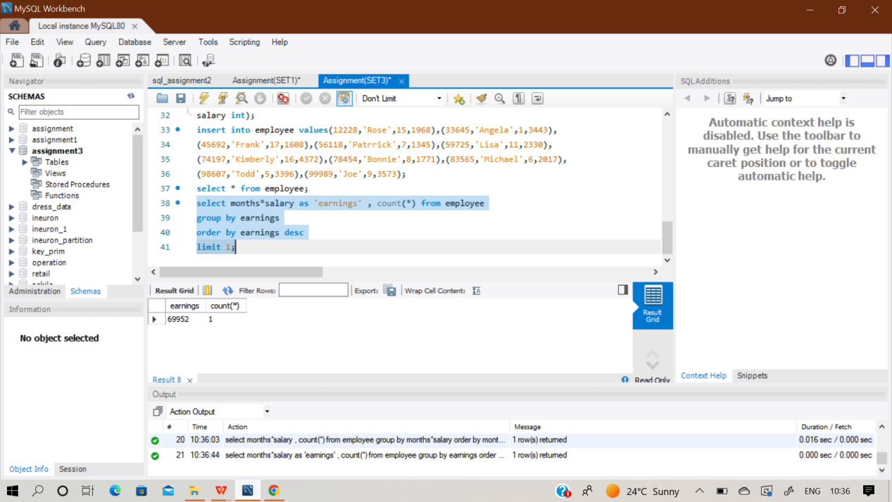

**select months*salary as 'earnings' , count(*) from employee**

**group by earnings**

**order by earnings desc**

**limit 1;**

**Q109) Query the number of occurrences of each occupation in OCCUPATIONS. Sort the occurrences in ascending order, and output them in the following format:**

Sol)At first create an empty table named ‘occupations’ and then insert records in it using multi insert statement.

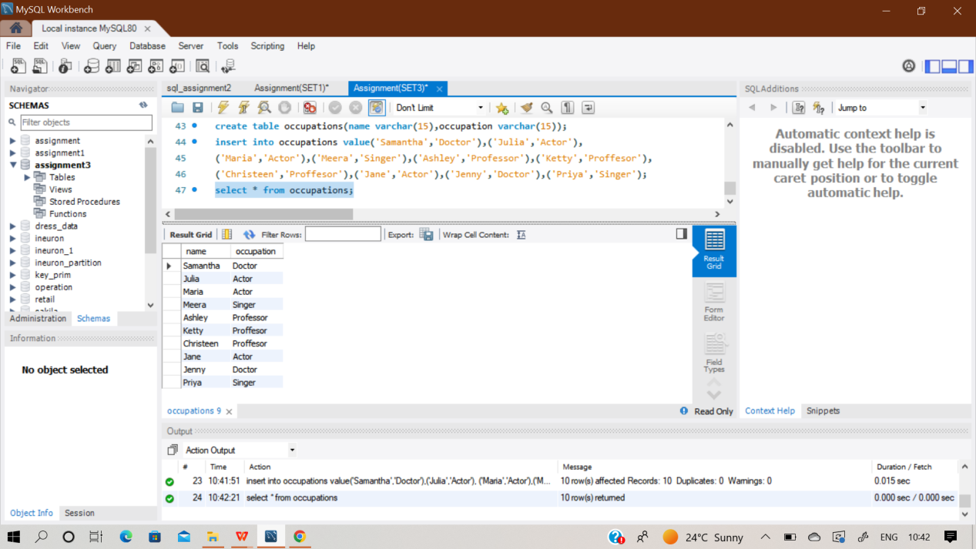

**select concat(name,'(',left(occupation, 1),')') as sample_output**

**from occupations**

**order by name;**

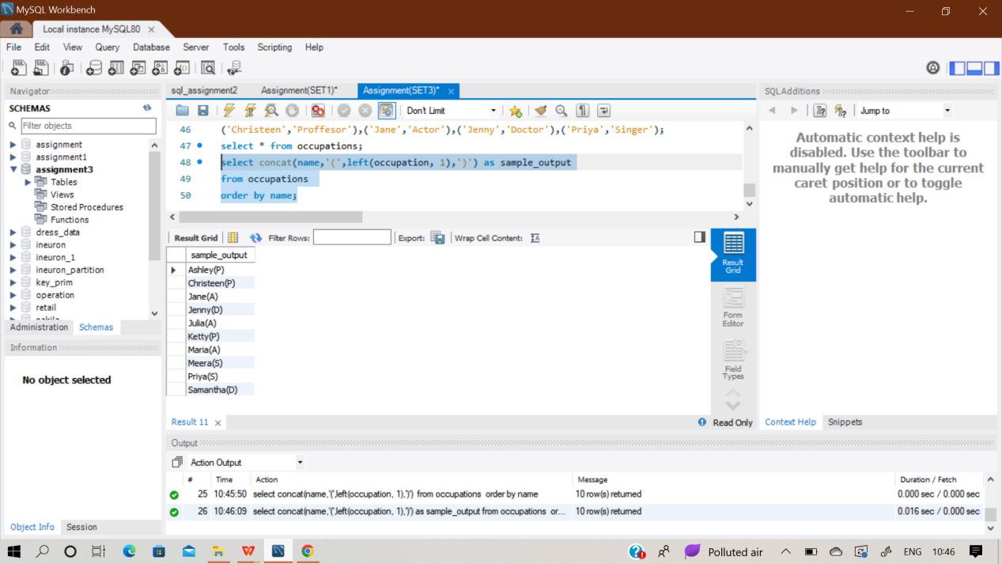

**Q110) Pivot the Occupation column in OCCUPATIONS so that each Name is sorted alphabetically and displayed underneath its corresponding Occupation. The output column headers should be Doctor, Professor, Singer, and Actor, respectively.**

**Note: Print NULL when there are no more names corresponding to an occupation.**

Sol)The table ‘Occupations’ used for this query is already created in previous question.

**select Doctor,Professor,Singer,Actor**

**from (select NameOrder,**

**max(case Occupation when 'Doctor' then Name end) as Doctor,**

**max(case Occupation when 'Professor' then Name end) as Professor,**

**max(case Occupation when 'Singer' then Name end) as Singer,**

**max(case Occupation when 'Actor' then Name end) as Actor**

**from (select Occupation,Name,**

**row_number() over(partition by Occupation order by Name ASC) as NameOrder**

**from Occupations**

**)as NameLists group by NameOrder**

**) as Names;**

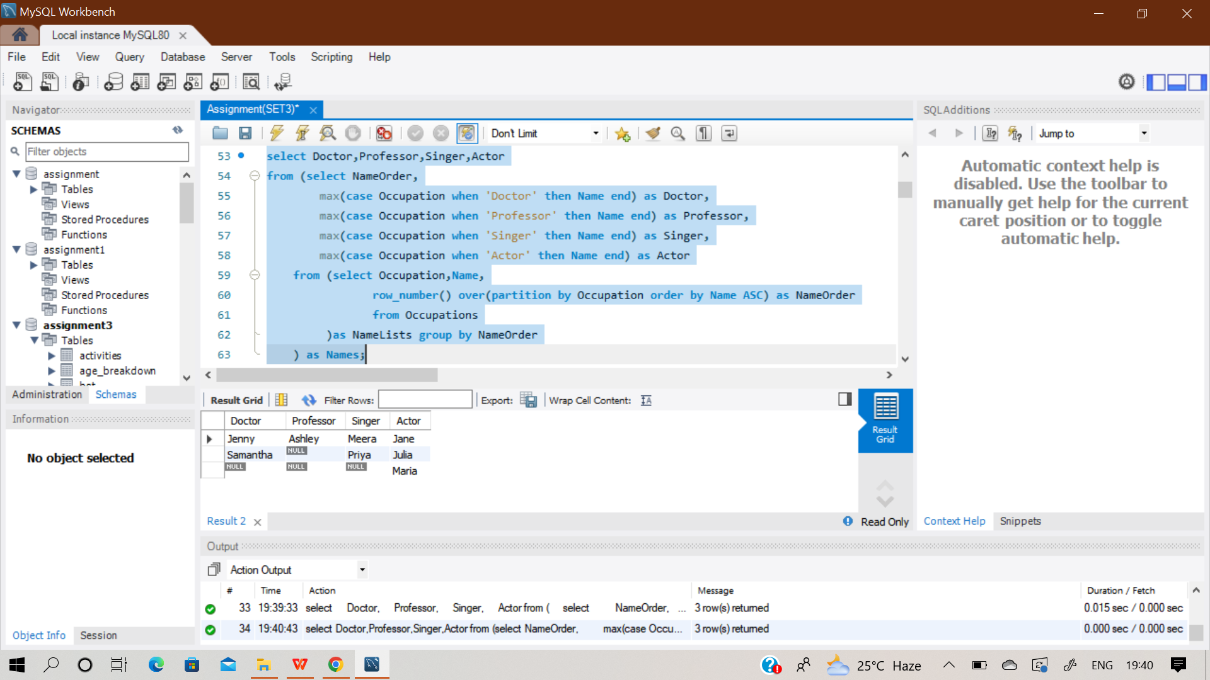

**Q111) Write a query to find the node type of Binary Tree ordered by the value of the node. Output one of the**

**following for each node:**

**● Root: If node is root node.**

**● Leaf: If node is leaf node.**

**● Inner: If node is neither root nor leaf node**

**Sol)** At first create an empty table named ‘BST’ and then insert records in it using multi insert statement.

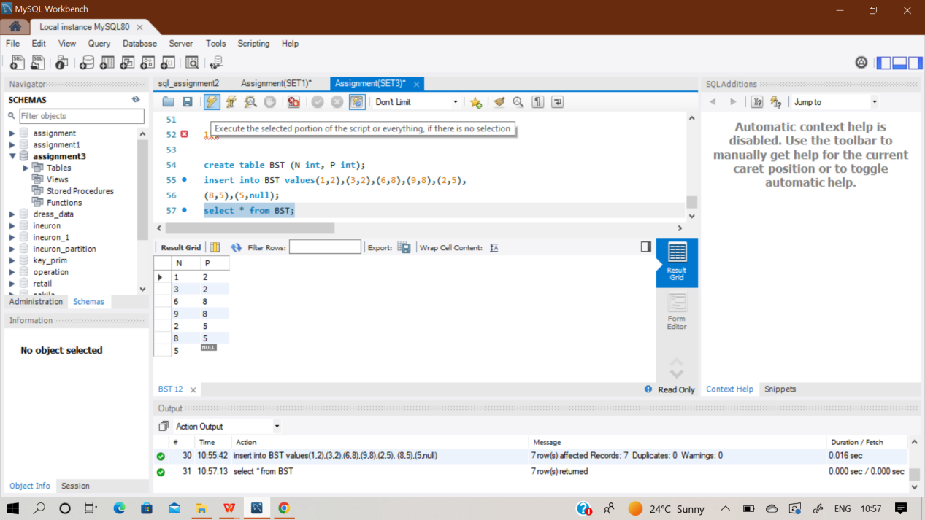

**select N,**

**(case when N not in (select distinct P from BST where P is not null) then 'Leaf'**

**when P is null then 'Root'**

**else 'Inner'**

**end ) as 'sample_output'**

**from BST;**

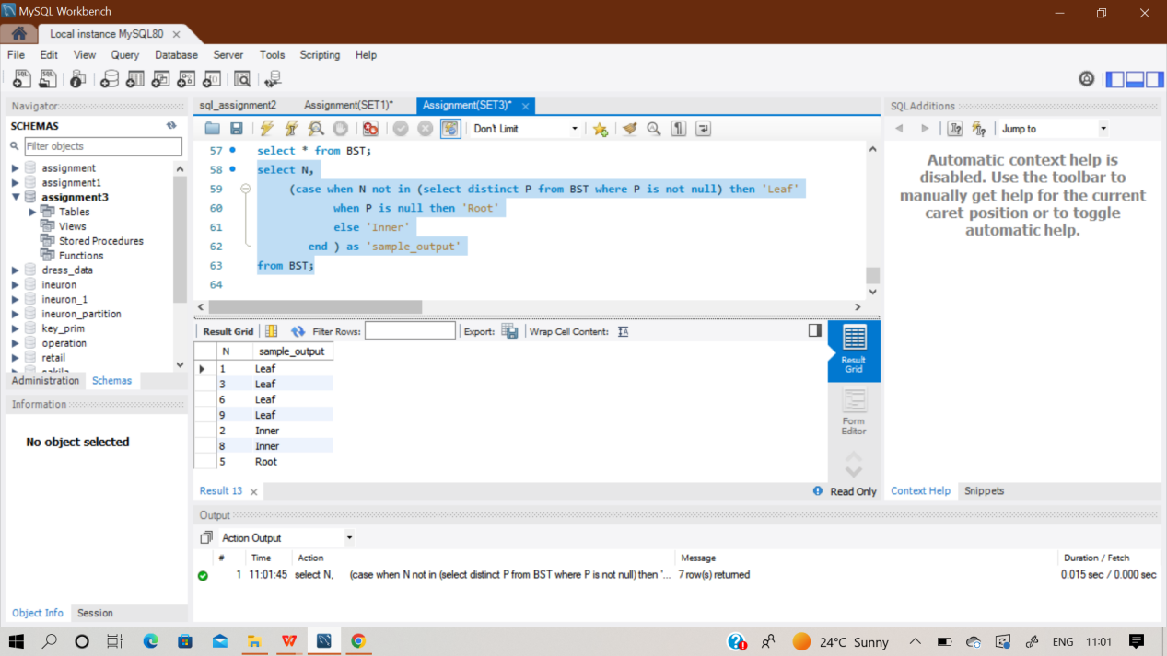

**Q112) Given the table schemas below, write a query to print the company_code, founder name, total number of lead managers, total number of senior managers, total number of managers, and total number of employees. Order your output by ascending company_code.**

Sol) In this question, we have to first create 5 empty tables naming ‘Company’,’Lead_manager’,’Senior_manager’,’Manager’, ‘Emp’ and then insert records in it using multi insert statement.

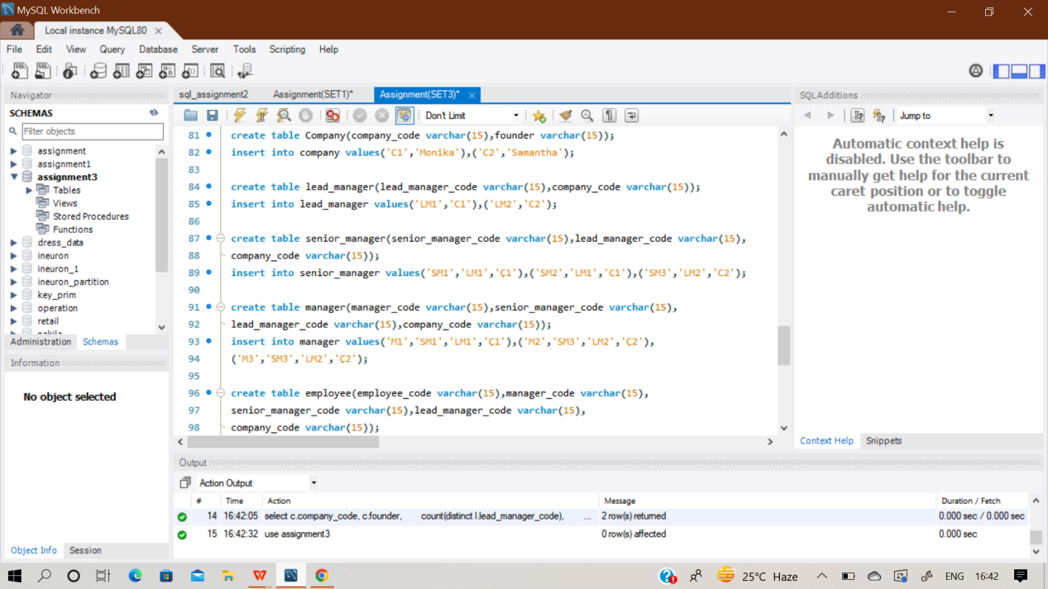

**select c.company_code, c.founder,**

**count(distinct l.lead_manager_code),**

**count(distinct s.senior_manager_code),**

**count(distinct m.manager_code),**

**count(distinct e.employee_code)**

**from Company as c join Lead_Manager as l**

**on c.company_code = l.company_code**

**join Senior_Manager as s on l.lead_manager_code =s.lead_manager_code**

**join Manager as m on m.senior_manager_code = s.senior_manager_code**

**join Employee as e on e.manager_code = m.manager_code**

**group by c.company_code, c.founder**

**order by c.company_code;**

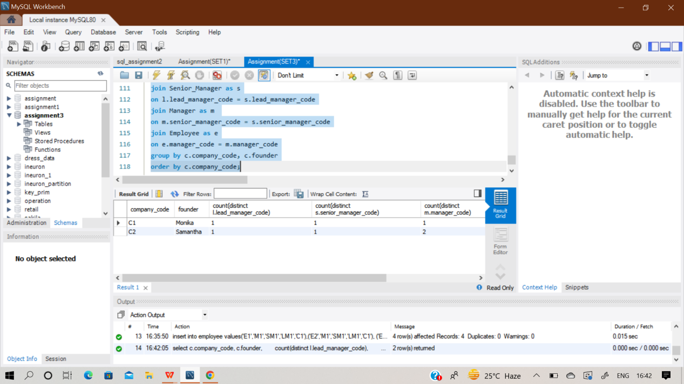

**Q113) Write a query to print all prime numbers less than or equal to 1000. Print your result on a single line, and use the ampersand () character as your separator (instead of a space). For example, the output for all prime numbers <=10 would be: 2&3&5&7**

**Q114) P(R) represents a pattern drawn by Julia in R rows. The following pattern represents P(5):**

**\***

**\* \***

**\* * \***

**\* * * \***

**\* * * * \***

**Write a query to print the pattern P(20)**

**Sol) set @number = 0;**

**select repeat('* ', @number := @number + 1)**

**from information_schema.tables**

**where @number < 20**

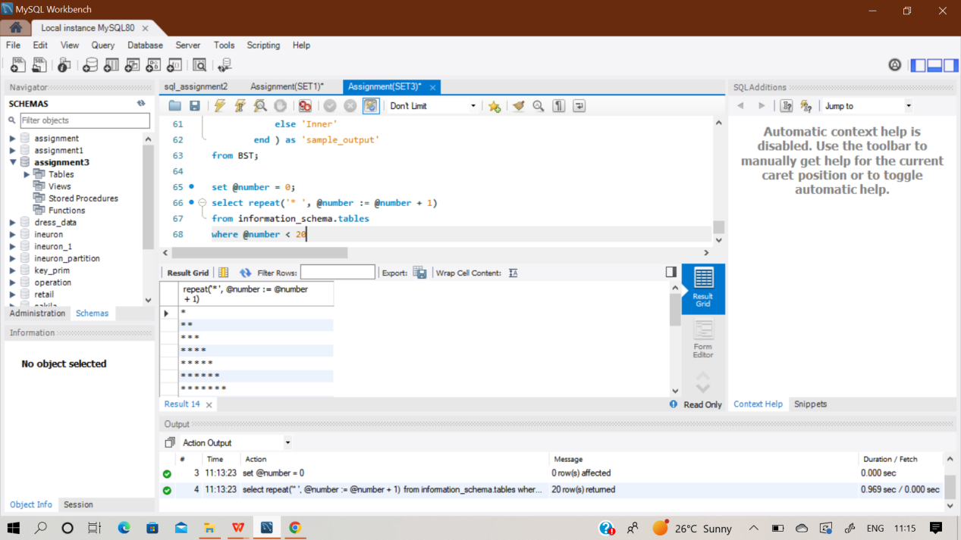

**Q115) P(R) represents a pattern drawn by Julia in R rows. The following pattern represents P(5):**

**\* * * * \***

**\* * * \***

**\* * \***

**\* \***

**\***

**Write a query to print the pattern P(20)**

**Sol) set @i = 21;**

**select repeat('* ', @i := @i-1)**

**from information_schema.tables;**

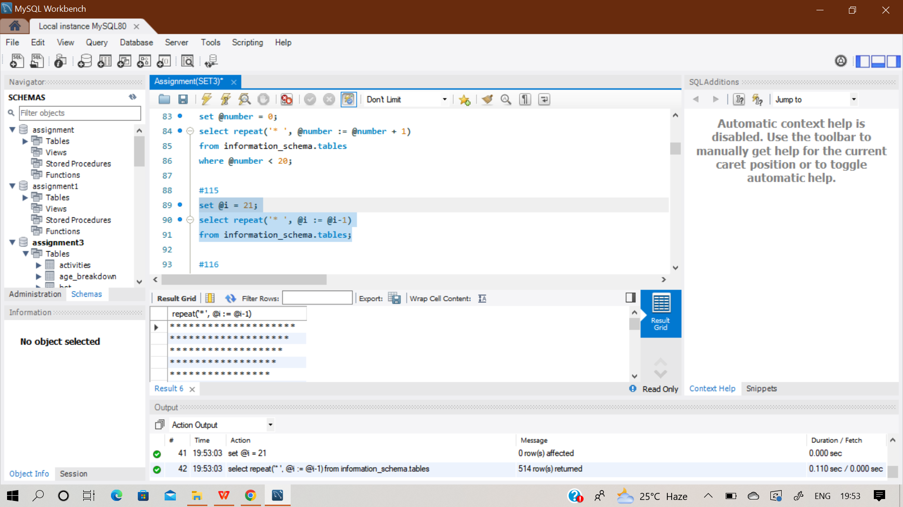

**Q116) Two pairs (X1, Y1) and (X2, Y2) are said to be symmetric pairs if X1 = Y2 and X2 = Y1.**

**Write a query to output all such symmetric pairs in ascending order by the value of X. List the rows**

**such that X1 ≤ Y1.**

Sol) At first create an empty table ‘sample’ and insert values in it.

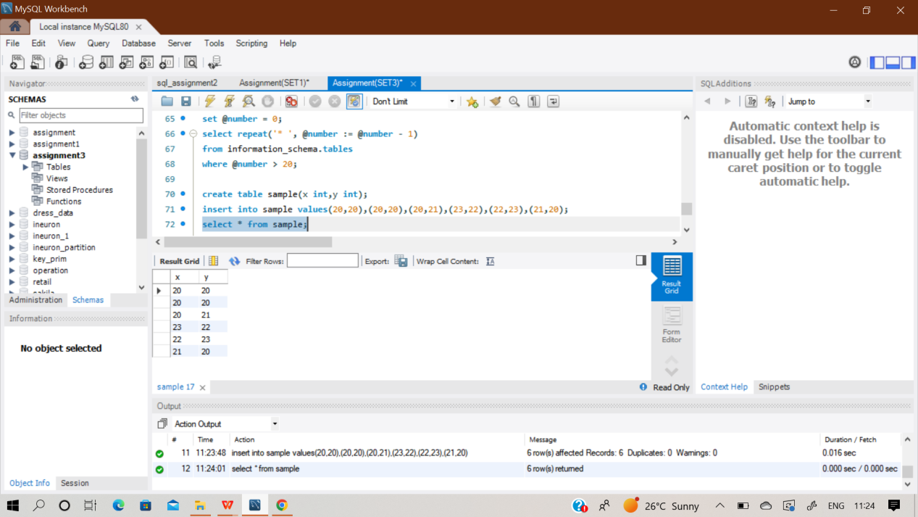

**select f1.x,f1.y**

**from sample f1, sample f2**

**where f1.x=f2.y and f1.y=f2.x**

**group by f1.x,f1.y**

**having count(f1.x)>1 or f1.x<f1.y**

**order by f1.x;**

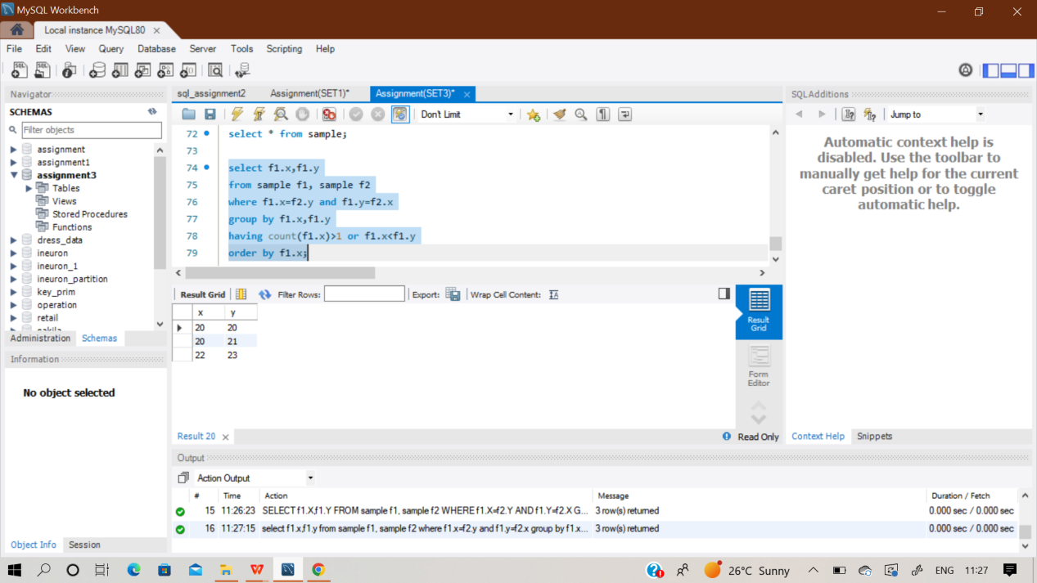

**Q117) SAME QUESTION AS Q103**

**Q118) SAME QUESTION AS Q104**

**Q119) SAME QUESTION AS Q105**

**Q120) SAME QUESTION AS Q106**

**Q121) SAME QUESTION AS Q85**

**Q122) SAME QUESTION AS Q86**

**Q123) SAME QUESTION AS Q87**

**Q124) SAME QUESTION AS Q88**

**Q125) SAME QUESTION AS Q89**

**Q126) SAME QUESTION AS Q90**

**Q127) SAME QUESTION AS Q91**

**Q128) SAME QUESTION AS Q92**

**Q129) SAME QUESTION AS Q93**

**Q130) SAME QUESTION AS Q94**

**Q131) SAME QUESTION AS Q95**

**Q132) SAME QUESTION AS Q96**

**Q133) SAME QUESTION AS Q97**

**Q134) SAME QUESTION AS Q98**

**Q135) SAME QUESTION AS Q99**

**Q136) SAME QUESTION AS Q100**

**Q137) SAME QUESTION AS Q101**

**Q138) SAME QUESTION AS Q137**

**Q139) SAME QUESTION AS Q103**

**Q140) SAME QUESTION AS Q104**

**Q141) SAME QUESTION AS Q105**

**Q142) SAME QUESTION AS Q106**

**Q143) SAME QUESTION AS Q107**

**Q144) SAME QUESTION AS Q108**

**Q145) SAME QUESTION AS Q109**

**Q146) SAME QUESTION AS Q110**

**Q147) SAME QUESTION AS Q111**

**Q148) SAME QUESTION AS Q112**

**Q149) SAME QUESTION AS Q113**

**Q150) Write a query to output the names of those students whose best friends got offered a higher salary than them. Names must be ordered by the salary amount offered to the best friends. It is guaranteed that no two students get the same salary offer.**

Sol) At first create an empty 3 table ‘Students’,’friends’ & ‘packages’ and insert values in it.

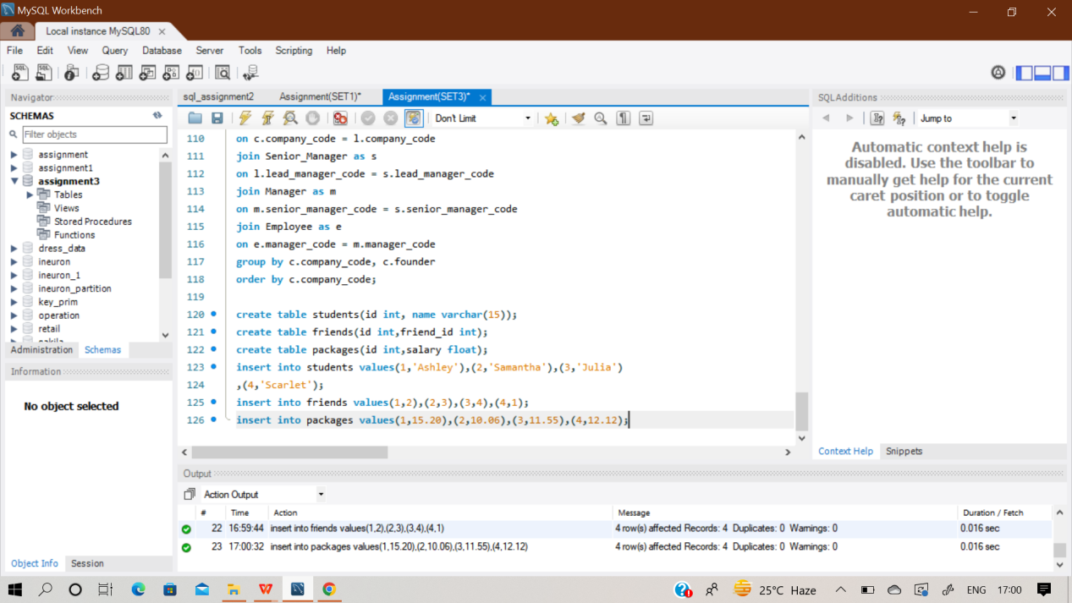

**select S1.Name from Students s1**

**inner join Packages p1 on s1.Id = p1.Id**

**inner join Friends f on s1.id = f.Id**

**inner join Students s2 on f.Friend_Id = s2.Id**

**inner join Packages p2 on s2.id = p2.Id**

**where p1.Salary < p2.Salary**

**order by p2.Salary ;**

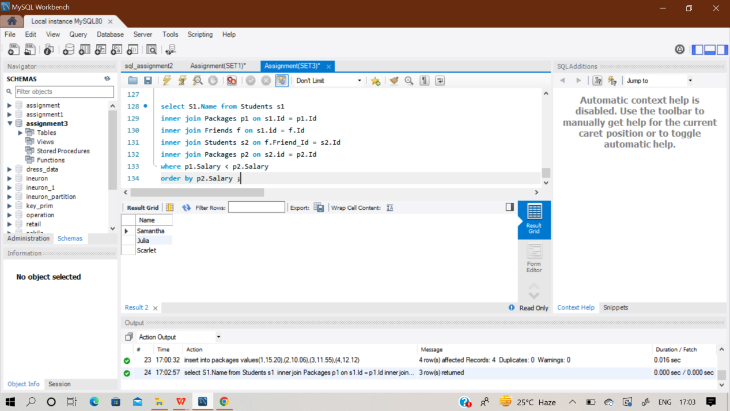

**Q151) Julia just finished conducting a coding contest, and she needs your help assembling the leaderboard! Write a query to print the respective hacker_id and name of hackers who achieved full scores for more than one challenge. Order your output in descending order by the total number of challenges in which the hacker earned a full score. If more than one hacker received full scores in the same number of challenges, then sort them by ascending hacker_id.**

Sol) At first create an empty 4 table‘Hackers’,’Difficulty’ ,’Challenges’& ‘Submissions’ and insert values in it.

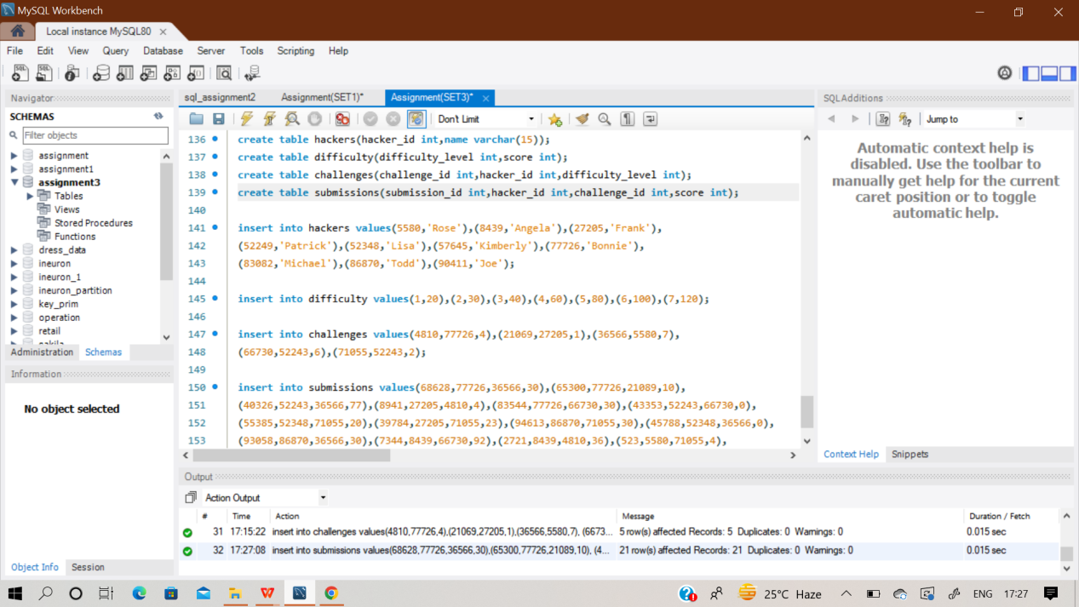

**select s.hacker_id, name from submissions as s**

**join hackers as h on s.hacker_id = h.hacker_id**

**join challenges as c on s.challenge_id = c.challenge_id**

**join difficulty as d on c.difficulty_level = d.difficulty_level**

**where s.score = d.score**

**group by name, s.hacker_id**

**having count(s.challenge_id) > 1**

**order by count(s.challenge_id) desc, s.hacker_id;**

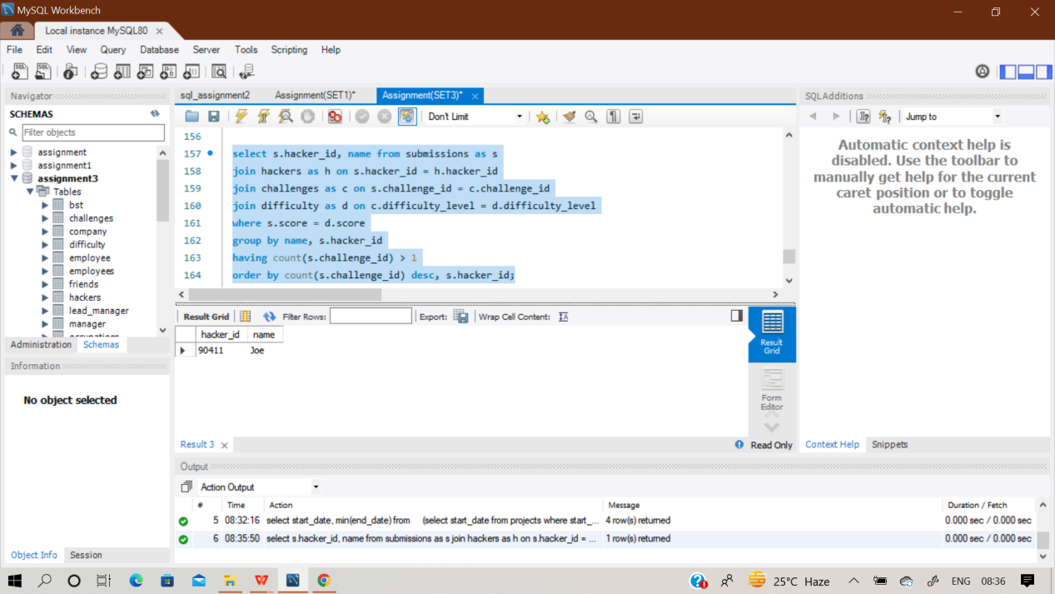

**Q152) Write a query to output the start and end dates of projects listed by the number of days it took to complete the project in ascending order. If there is more than one project that have the same number of completion days, then order by the start date of the project.**

Sol) At first create an empty table ‘projects’ and insert values in it using multi insert statement.

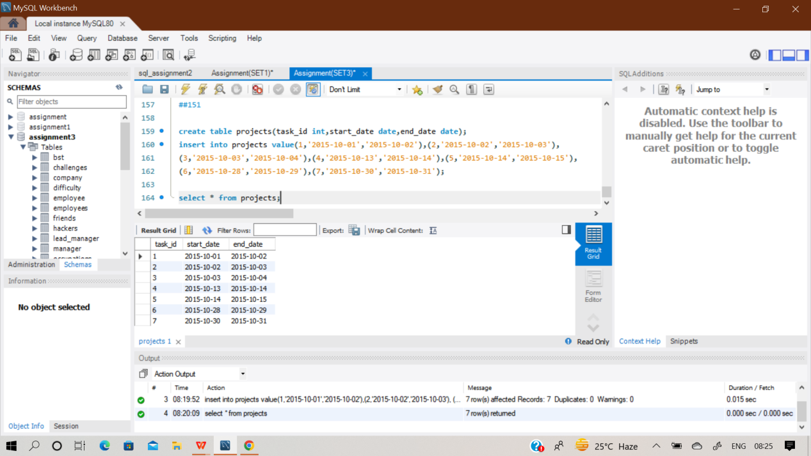

**select start_date, min(end_date)**

**from**

**(select start_date from projects where start_date not in (select end_date from projects))a,**

**(select end_date from projects where end_date not in (select start_date from projects))b**

**where start_date < end_date**

**group by start_date**

**order by datediff(min(end_date), start_date) asc, start_date asc;**

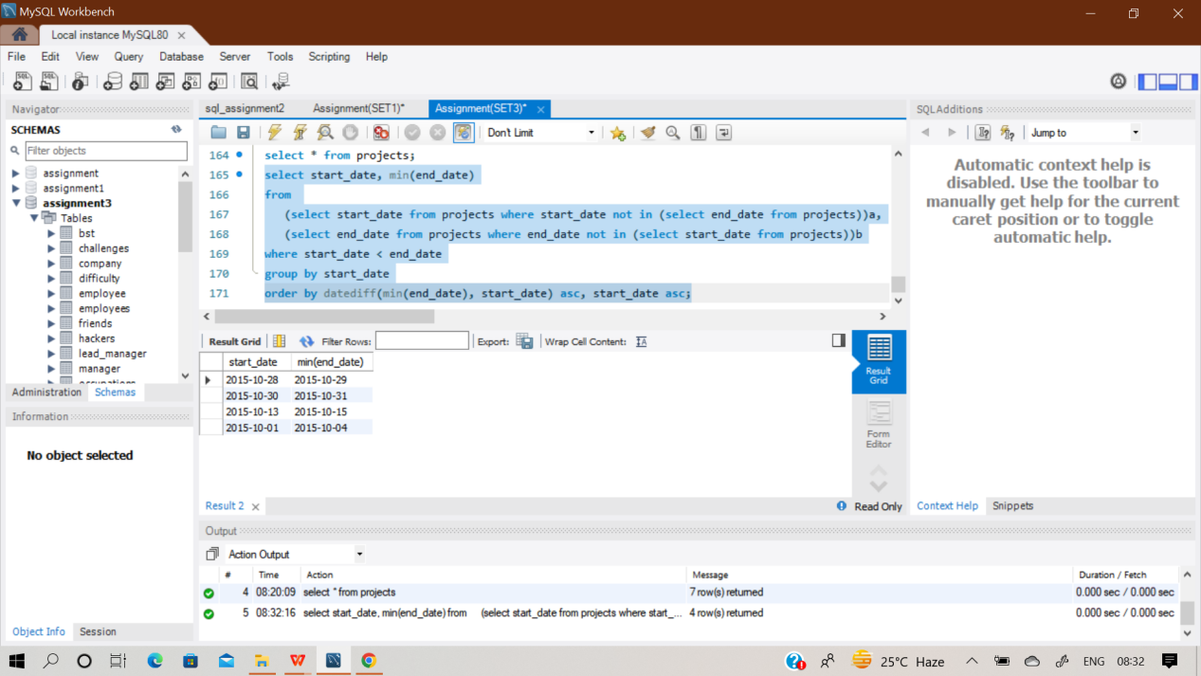

**Q153) In an effort to identify high-value customers, Amazon asked for your help to obtain data about users who go on shopping sprees. A shopping spree occurs when a user makes purchases on 3 or more**

**consecutive days. List the user IDs who have gone on at least 1 shopping spree in ascending order.**

Sol) At first create an empty an table ‘trans’ and insert values in it.

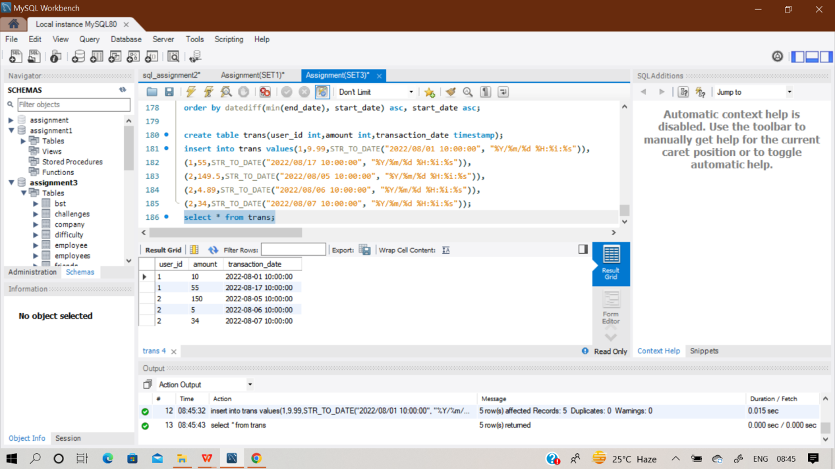

**with cte as (**

**select *, lead(date_diff,1) over(partition by user_id order by transaction_date**

**) - lead(date_diff,0) over(partition by user_id order by transaction_date)as'diff'**

**from (**

**select *,datediff(lead(transaction_date,1) over(partition by user_id order by**

**transaction_date), lead(transaction_date,0) over(partition by user_id order by**

**transaction_date)) as 'date_diff'**

**from trans) sub),**

**cte2 as (select user_id,date_diff,diff,**

**count(date_diff),count(diff) from cte**

**group by user_id,date_diff,diff**

**having count(date_diff) >= 2**

**and date_diff=1 or diff=0)**

**select user_id from cte2;**

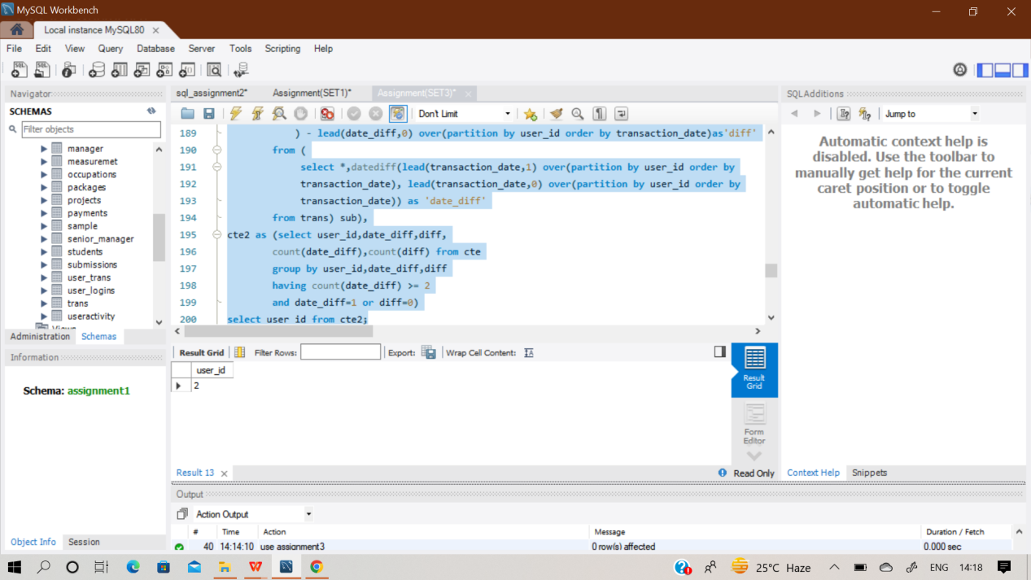

**Q154) You are given a table of PayPal payments showing the payer, the recipient, and the amount paid. A two-way unique relationship is established when two people send money back and forth. Write a**

**query to find the number of two-way unique relationships in this data.**

**Assumption:**

**● A payer can send money to the same recipient multiple times**

Sol) At first create an empty table ‘payments’ and insert values in it.

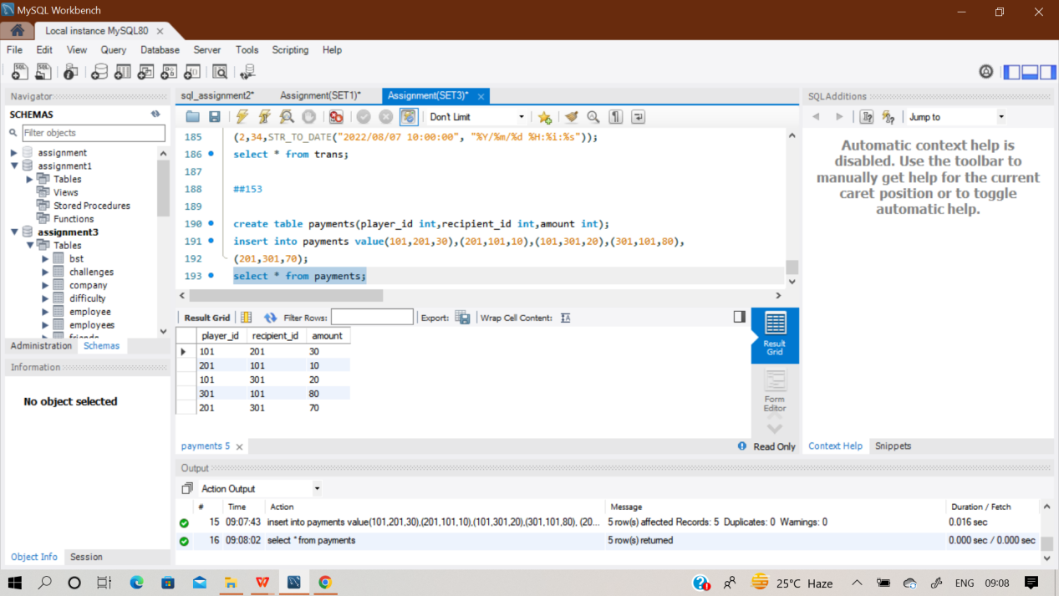

**with cte as**

**(select player_id, recipient_id from payments**

**intersect**

**Select recipient_id,player_id**

**from payments)**

**Select count(payer_id)/2 as unique_relationships**

**From cte;**

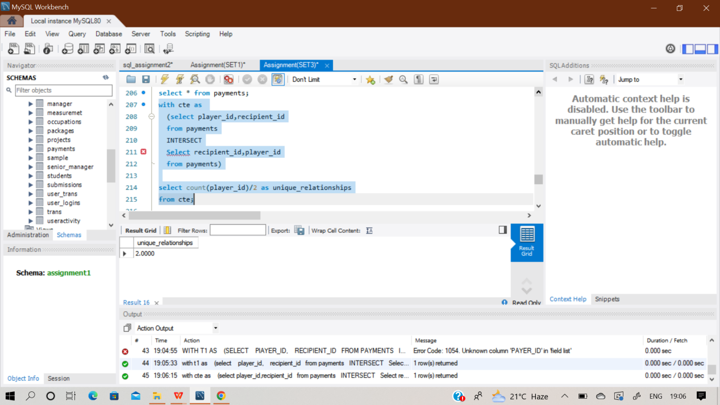

**Q155)Assume you are given the table below containing information on Facebook user logins. Write a query to obtain the number of reactivated users (which are dormant users who did not log in the previous month, then logged in during the current month).**

**Output the current month (in numerical) and number of reactivated users. Assumption:**

**● The rows in the user_logins table are complete for the year of 2022 and there are no missing**

**dates.**

Sol) At first create an empty table ‘user_logins’ and insert values in it using multi insert statement.

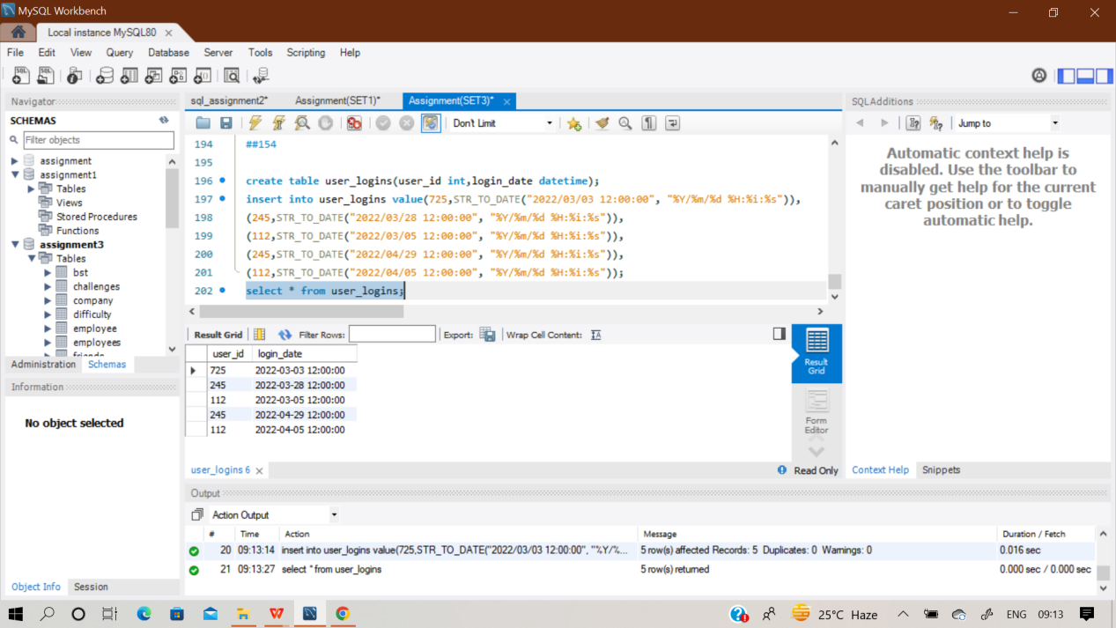

**Q156) Assume you are given the table below on user transactions. Write a query to obtain the list of customers whose first transaction was valued at $50 or more. Output the number of users.**

**Clarification:**

**● Use the transaction_date field to determine which transaction should be labeled as the first**

**for each user.**

**● Use a specific function (we can't give too much away!) to account for scenarios where a user**

**had multiple transactions on the same day, and one of those was the first.**

Sol) At first create an empty table ‘user_trans’ and insert values in it.

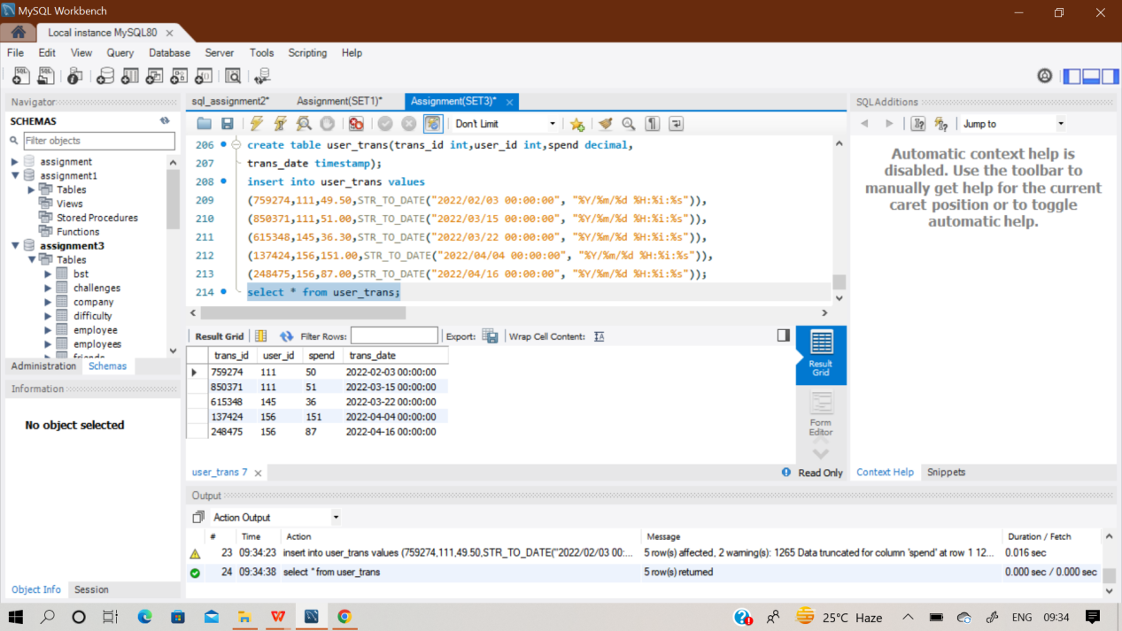

**with cte as (**

**select *, row_number() over(partition by user_id order by trans_date) as rn**

**from user_trans**

**order by user_id, trans_date )**

**select count(user_id) as users from cte where rn=1 and spend>=50;**

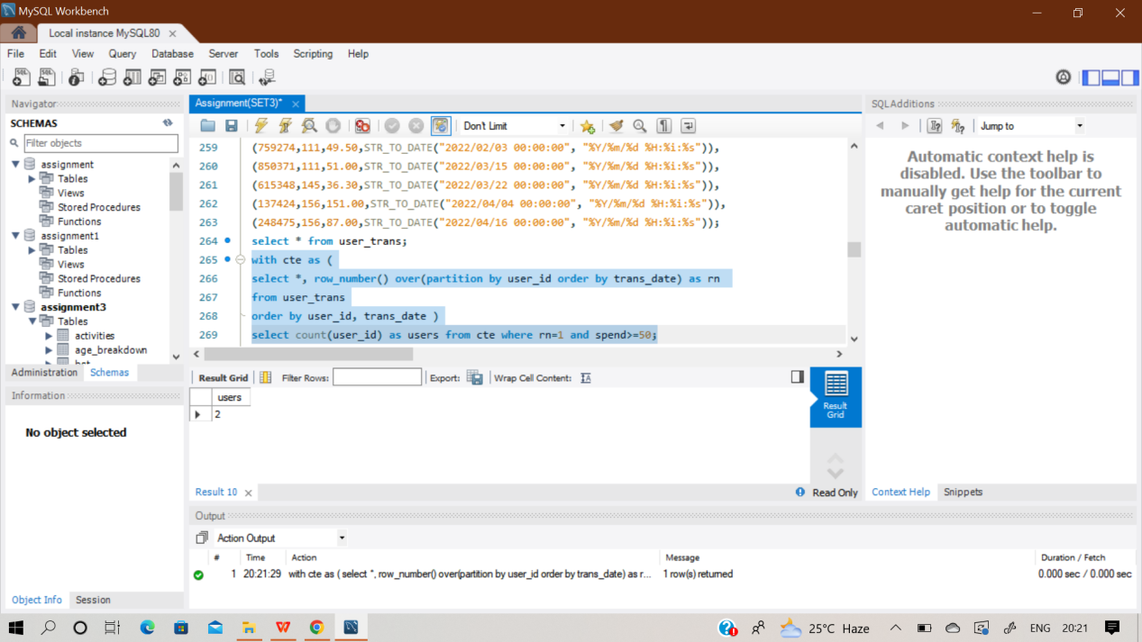

**Q157) Assume you are given the table below containing measurement values obtained from a sensor over several days. Measurements are taken several times within a given day. Write a query to obtain the sum of the odd-numbered and even-numbered measurements on a**

**particular day, in two different columns.**

**Note that the 1st, 3rd, 5th measurements within a day are considered odd-numbered measurements and the 2nd, 4th, 6th measurements are even-numbered measurements.**

Sol) At first create an empty table ‘Measurements’ and insert values in it.

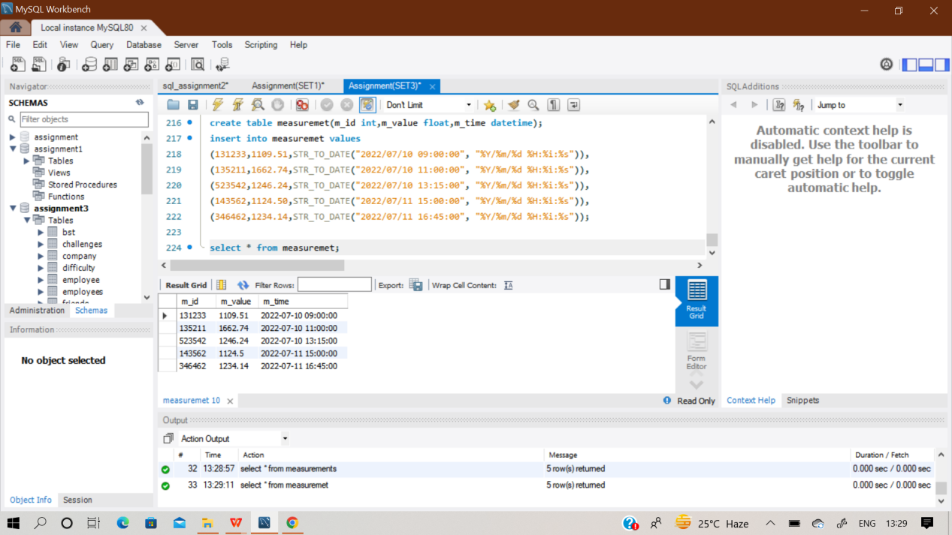

**with m as**

**(select cast(m_time as date) md, m_value mv,**

**row_number() over( partition by cast(m_time as date)**

**order by m_time) mn**

**from measuremet)**

**select md,sum(case when m.mn % 2 = 0 then mv else 0 end) as even_sum,sum(case when m.mn % 2 != 0 then mv else 0 end) as odd_sum from m**

**group by md;**

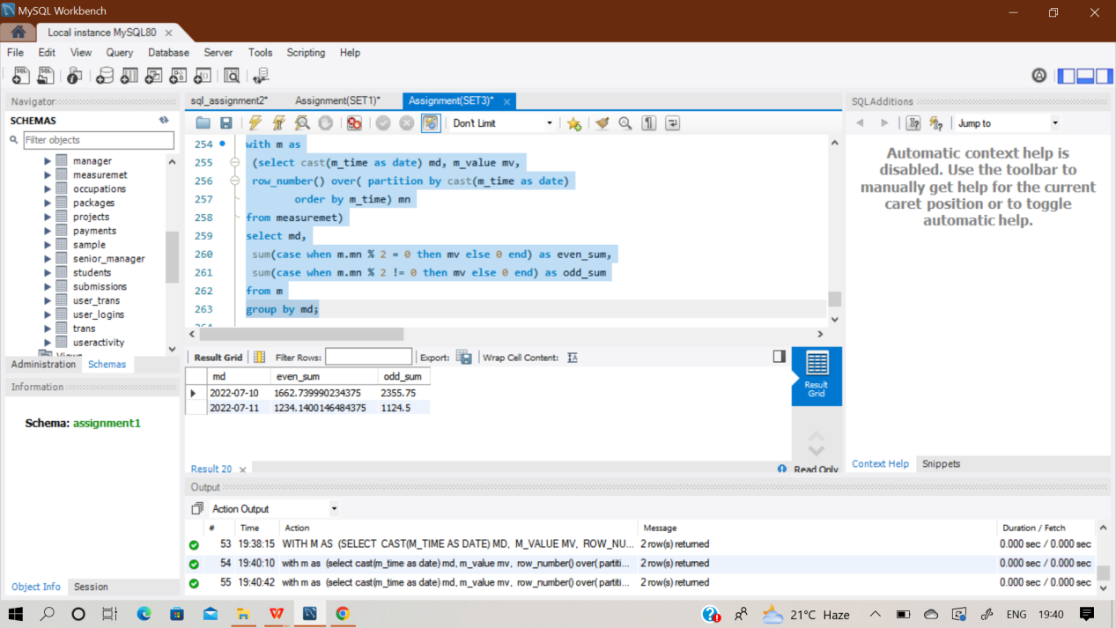

**Q158) In an effort to identify high-value customers, Amazon asked for your help to obtain data about users who go on shopping sprees. A shopping spree occurs when a user makes purchases on 3 or more**

**consecutive days. List the user IDs who have gone on at least 1 shopping spree in ascending order.**

Sol) At first create an empty table ‘Transaction’ and insert values in it.

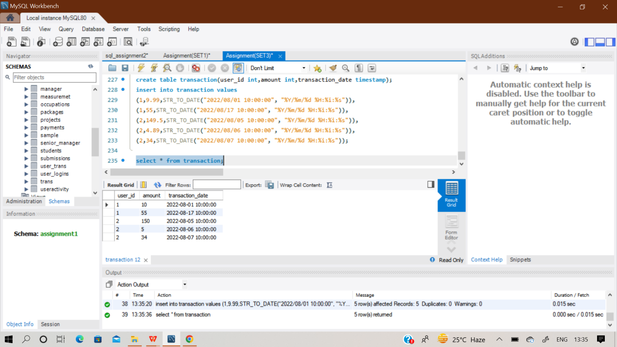

**with cte as (**

**select *,lead(date_diff, 1) over(partition by user_id**

**order by transaction_date) - lead(date_diff, 0) over(**

**partition by user_id order by transaction_date) as 'diff'**

**from( select *, datediff(lead(transaction_date, 1) over(partition by user_id**

**order by transaction_date),lead(transaction_date, 0) over(partition by user_id**

**order by transaction_date)) as 'date_diff'**

**from transaction) sub),**

**cte2 as (select user_id,date_diff,diff,count(date_diff),count( diff )**

**from cte group by user_id,date_diff,diff**

**having count(date_diff) >= 2 and date_diff = 1 or diff = 0)**

**select user_id from cte2;**

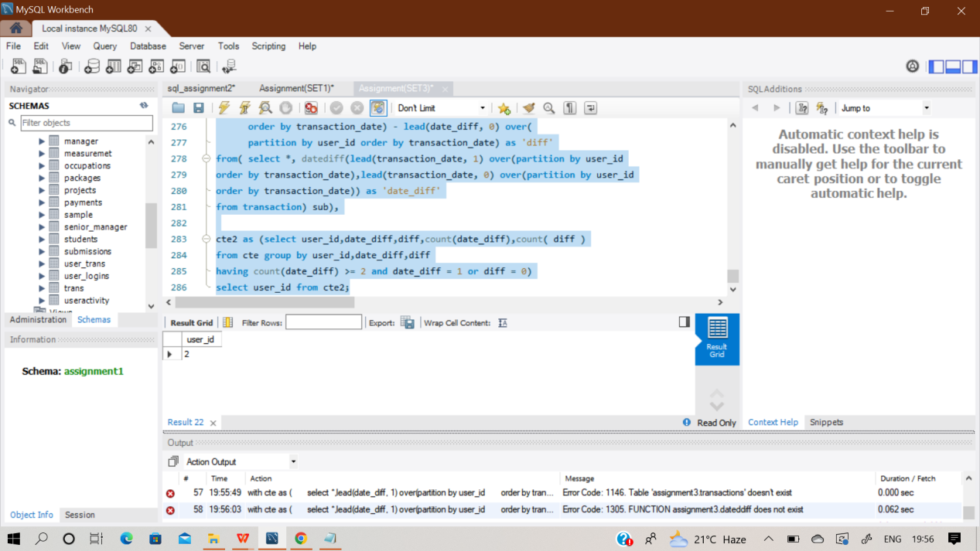

**Q159) The Airbnb Booking Recommendations team is trying to understand the "substitutability" of two rentals and whether one rental is a good substitute for another. They want you to write a query to find the unique combination of two Airbnb rentals with the same exact amenities offered. Output the count of the unique combination of Airbnb rentals**.

**Assumptions:**

**● If property 1 has a kitchen and pool, and property 2 has a kitchen and pool too, it is a good**

**substitute and represents a unique matching rental.**

**● If property 3 has a kitchen, pool and fireplace, and property 4 only has a pool and fireplace,**

**then it is not a good substitute.**

Sol) At first create an empty 4 table‘Hackers’,’Difficulty’ ,’Challenges’& ‘Submissions’ and insert values in it.

**Q160) Google marketing managers are analysing the performance of various advertising accounts over the last month. They need your help to gather the relevant data. Write a query to calculate the return on ad spend (ROAS) for each advertiser across all ad campaigns.**

**Round your answer to 2 decimal places, and order your output by the advertiser_id.**

Sol) At first create an empty 4 table‘Hackers’,’Difficulty’ ,’Challenges’& ‘Submissions’ and insert values in it.

**Q161) An employee is considered to be potentially overpaid if they earn more than 2 times the average salary for people with the same title. Similarly, an employee might be underpaid if they earn less than half of the average for their title. We'll refer to employees who are both underpaid and overpaid as compensation outliers for the purposes of this problem.**

**Write a query that shows the following data for each compensation outlier: employee ID, salary, and**

**whether they are potentially overpaid or potentially underpaid (refer to Example Output below).**

Sol)

**Q162) SAME AS Q154)**

**Q163) Assume you are given the table below containing information on user purchases. Write a query to obtain the number of users who purchased the same product on two or more different days. Output**

**the number of unique users.**

***PS. On 26 Oct 2022, we expanded the purchases data set, thus the official output may vary from before.***

Sol) At first create an empty table ‘purchases’ and insert values in it.

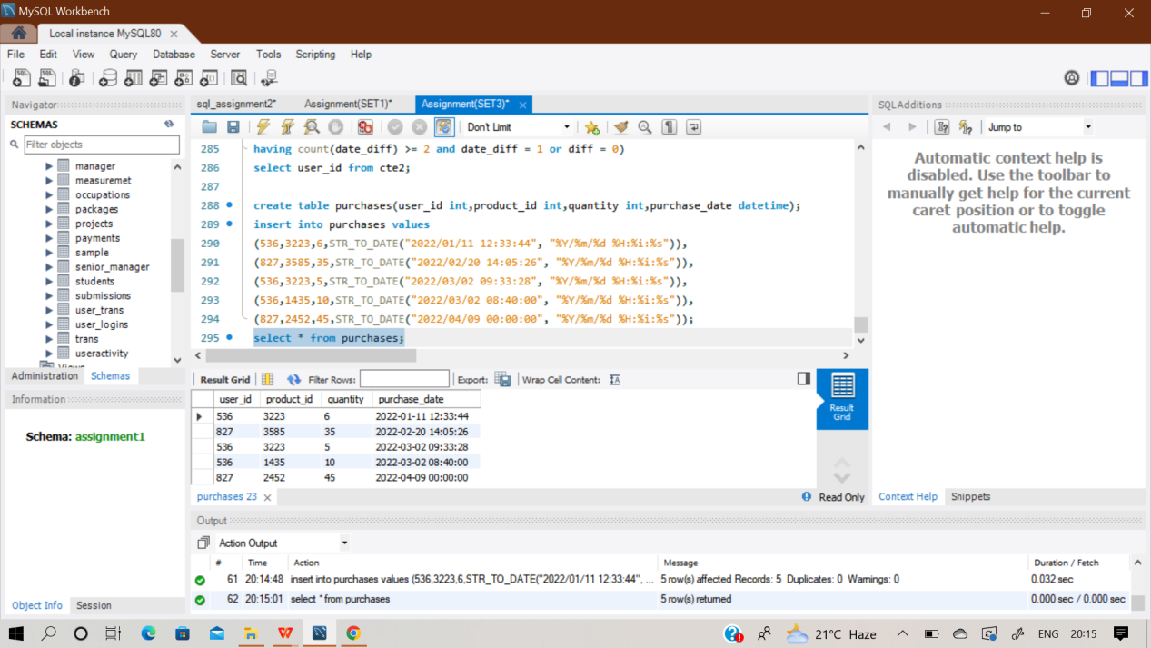

**select count(distinct user_id) as repeat_purchases**

**from ( select user_id, rank() over (partition by user_id, product_id**

**order by date(purchase_date) asc**

**) as purchase_no**

**from purchases**

**) as ranking where purchase_no = 2;**

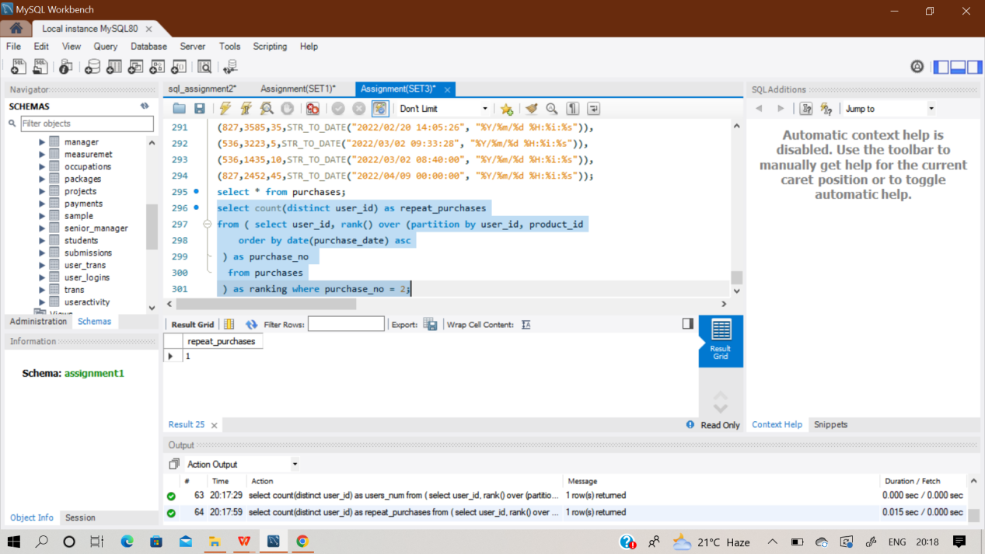

**Q164) Assume you are given the table below containing the information on the searches attempted and the**

**percentage of invalid searches by country. Write a query to obtain the percentage of invalid searches. Output the country in ascending order, total searches and overall percentage of invalid searches**

**rounded to 2 decimal places.**

Sol) At first create an empty table ‘Search_category’ and insert values in it.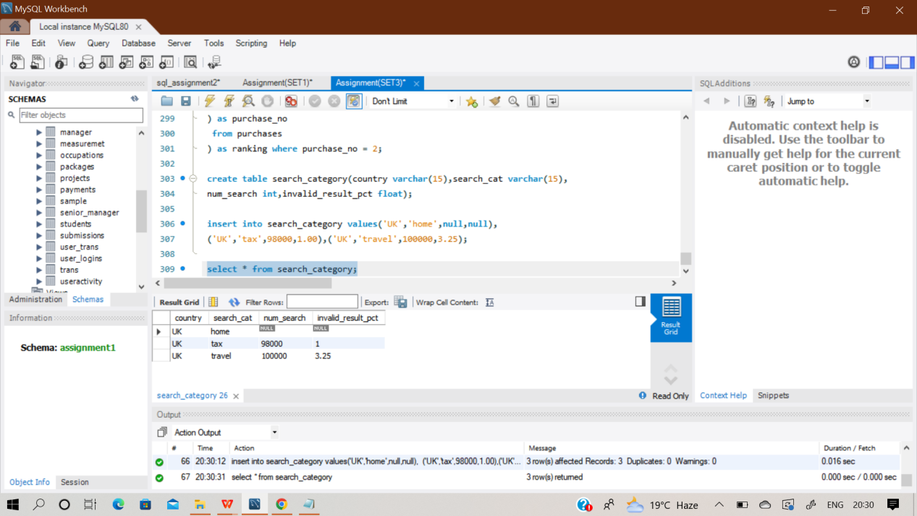

**with invalid_results**

**as (select country,num_search,invalid_result_pct,**

**(case when invalid_result_pct is not null then**

**num_search**

**else null end) as num_search_2,**

**round((num_search * invalid_result_pct)/100.0,0) as**

**invalid_search from search_category**

**where num_search is not null**

**and invalid_result_pct is not null**

**)**

**Select country,sum(num_search_2) as total_search,**

**round (sum(invalid_search) /sum(num_search_2) \***

**100.0,2) as invalid_result_pct**

**from invalid_results group by country order by country;**

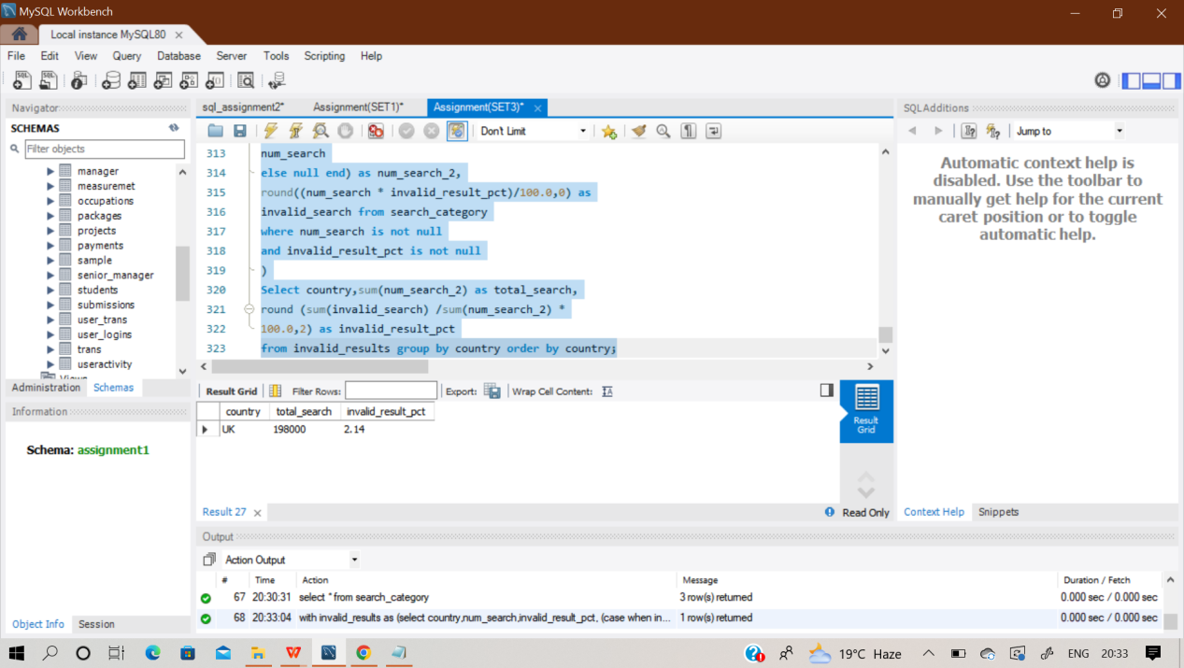

**Q165) Say you have access to all the transactions for a given merchant account. Write a query to print the cumulative balance of the merchant account at the end of each day, with the total balance reset back to zero at the end of the month. Output the transaction date and cumulative balance.**

**Hint-You should use CASE.**

Sol)

**Q166) Assume you are given the table below containing information on Amazon customers and their spend on products belonging to various categories. Identify the top two highest-grossing products within each category in 2022. Output the category, product, and total spend.**

Sol) At first create an empty 4 table ’product_spend and insert values in it.

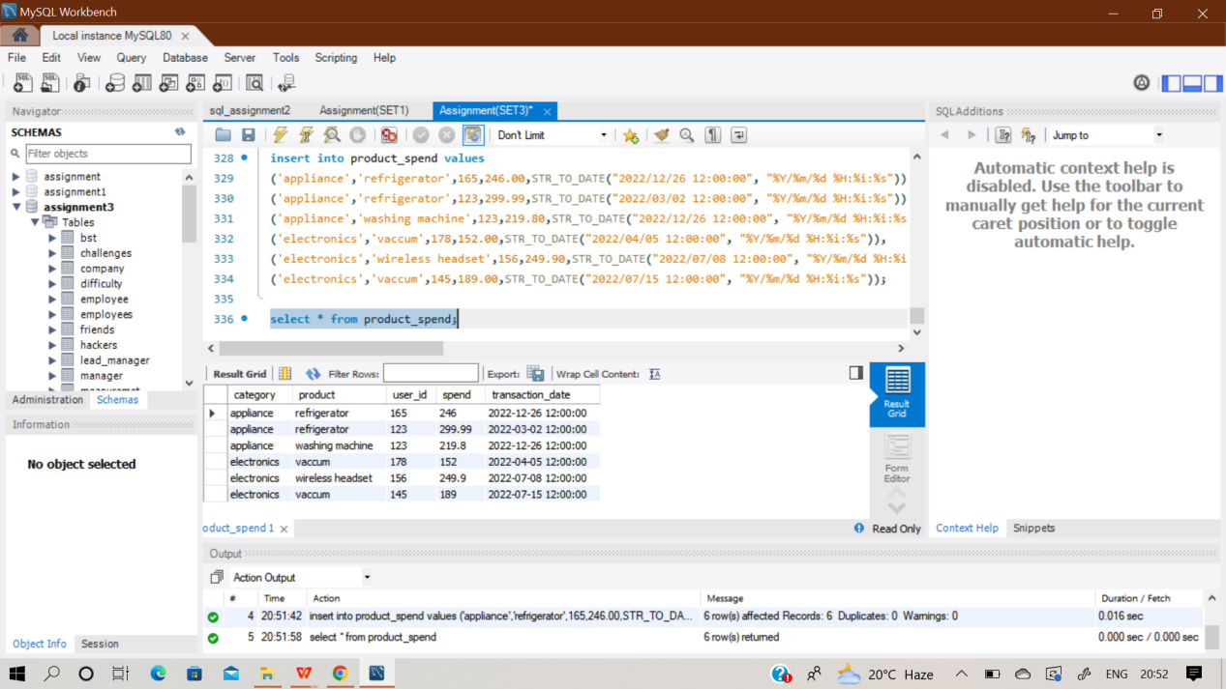

**select category, product, total_spend from (**

**select *, rank() over ( partition by category**

**order by total_spend desc) as ranking**

**from ( select category, product, sum(spend) as total_spend**

**from product_spend where transaction_date >= '2022-01-01'**

**and transaction_date <= '2022-12-31'**

**group by category, product) as total_spend**

**) as top_spend**

**where ranking <= 2**

**order by category, ranking;**

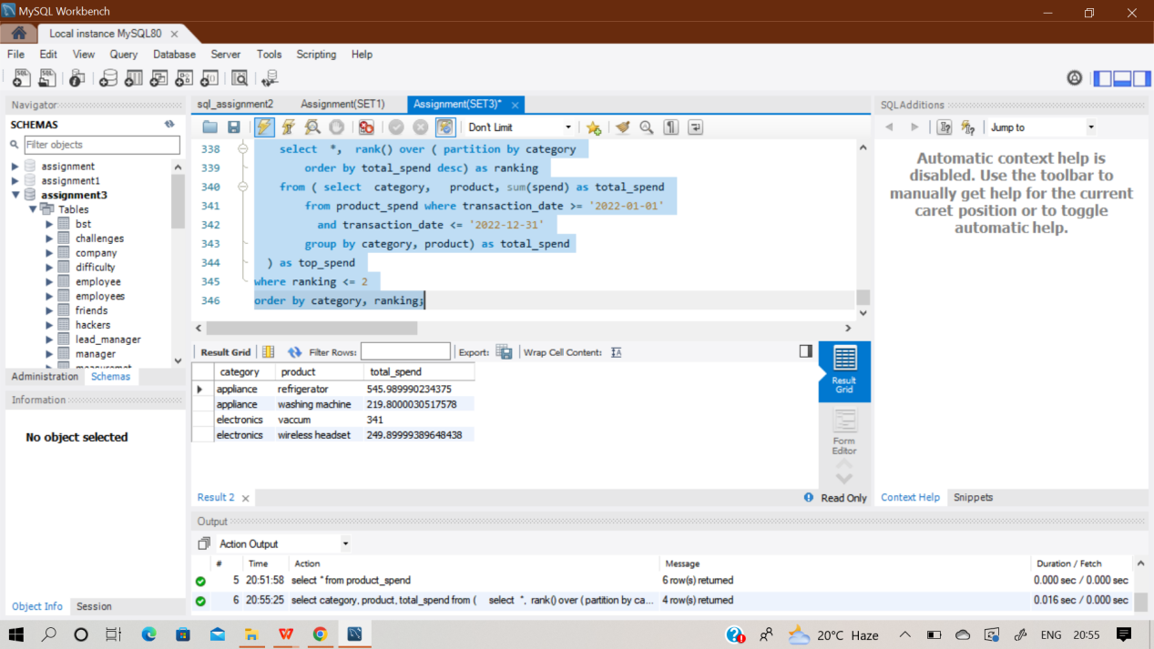

**Q167) Facebook is analysing its user signup data for June 2022. Write a query to generate the churn rate by week in June 2022. Output the week number (1, 2, 3, 4, ...) and the corresponding churn rate rounded to 2 decimal places.**

**For example, week number 1 represents the dates from 30 May to 5 Jun, and week 2 is from 6 Jun to 12 Jun.**

**Hint- Use Extract.**

**Assumptions:**

**● If the last_login date is within 28 days of the signup_date, the user can be considered**

**churned.**

**● If the last_login is more than 28 days after the signup date, the user didn't churn.**

**users Table:**

Sol)

**Q168) You're given two tables on Spotify users' streaming data. songs_history table contains the historical streaming data and songs_weekly table contains the current week's streaming data.**

**Write a query to output the user id, song id, and cumulative count of song plays as of 4 August 2022 sorted in descending order.**

**Hint- Use group by**

Sol) At first create 2 empty tables ‘Songs_weekly ’ & ’songs_history’ and insert values in it.

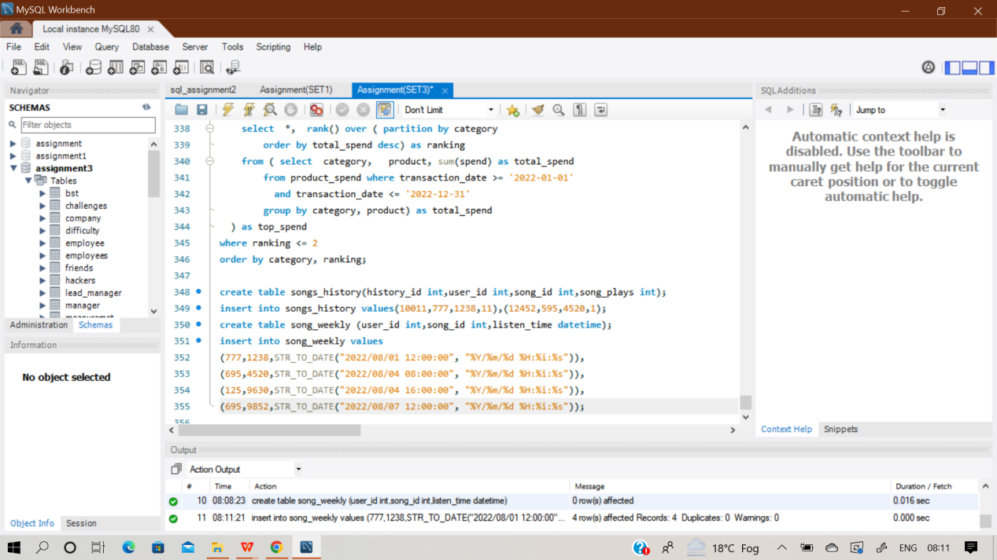

**select user_id, song_id, sum(song_plays) as song_count**

**from (**

**select user_id, song_id, song_plays from songs_history**

**union all**

**select user_id, song_id, count(song_id) as song_plays**

**from song_weekly**

**where listen_time <= '2022-08-04 23:59:59'**

**group by user_id, song_id**

**) as report**

**group by user_id, song_id**

**order by song_count desc;**

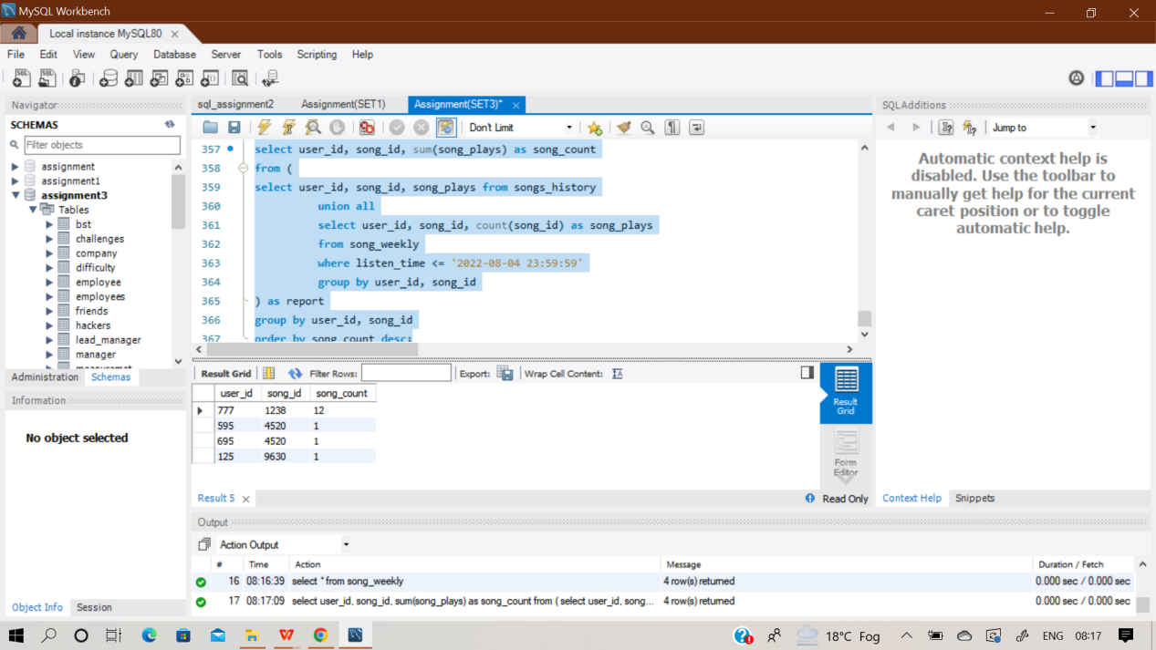

**Q169) New TikTok users sign up with their emails, so each signup requires a text confirmation to activate the new user's account.**

**Write a query to find the confirmation rate of users who confirmed their signups with text messages. Round the result to 2 decimal places.**

**Hint- Use Joins**

Sol) At first create 2 empty tables ‘Emails’ & ’Texts’ and insert values in it.

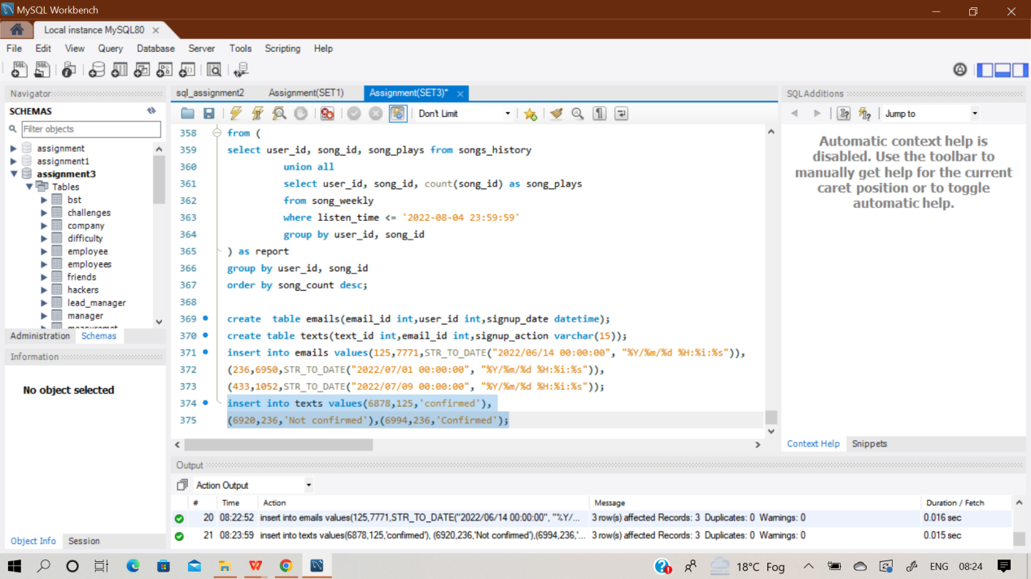

**Select round(sum(signup) / count(user_id), 2) as confirmation_rate from (**

**select user_id,**

**(case when texts.email_id is not null then 1**

**else 0**

**End) as signup**

**from emails**

**left join texts**

**on emails.email_id = texts.email_id**

**and signup_action = 'confirmed'**

**) as rate;**

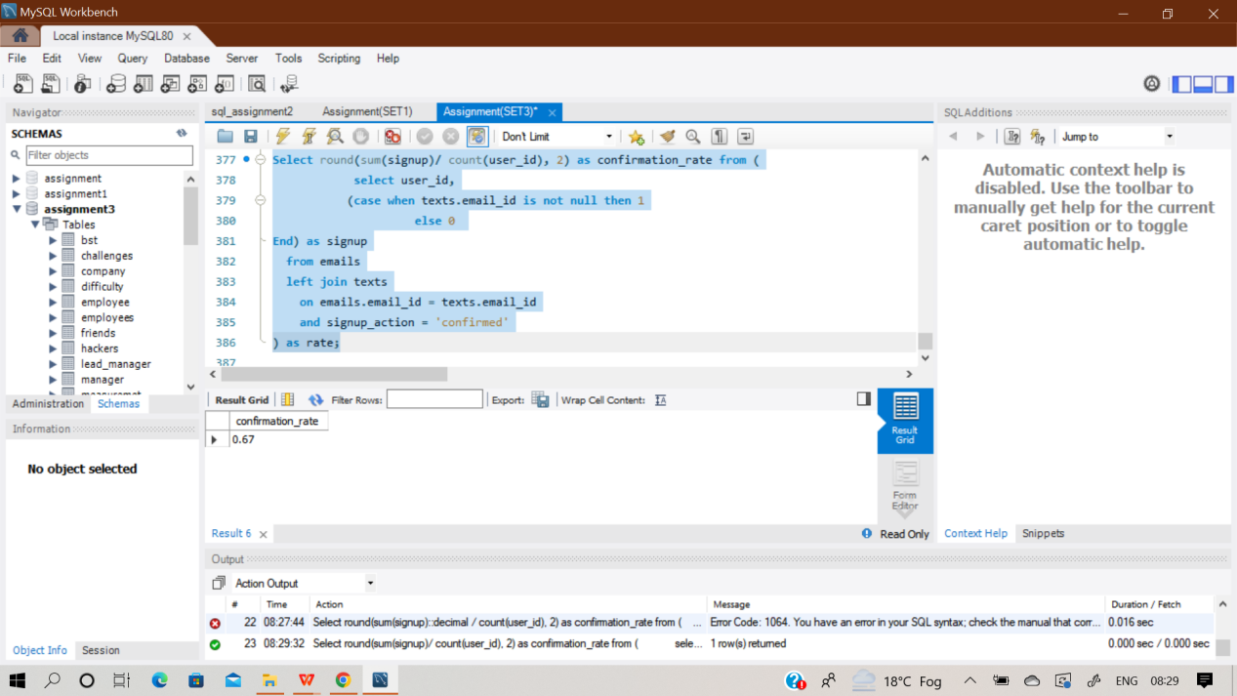

**Q170) The table below contains information about tweets over a given period of time. Calculate the 3-day rolling average of tweets published by each user for each date that a tweet was posted. Output the user id, tweet date, and rolling averages rounded to 2 decimal places.**

**Hint- Use Count and group by**

**Important Assumptions:**

**● Rows in this table are *consecutive* and ordered by date.**

**● Each row represents a different day**

**● A day that does not correspond to a row in this table is not counted. The most recent day is the next row above the current row**

Sol) At first create an empty table ‘Tweets’ and insert values in it.

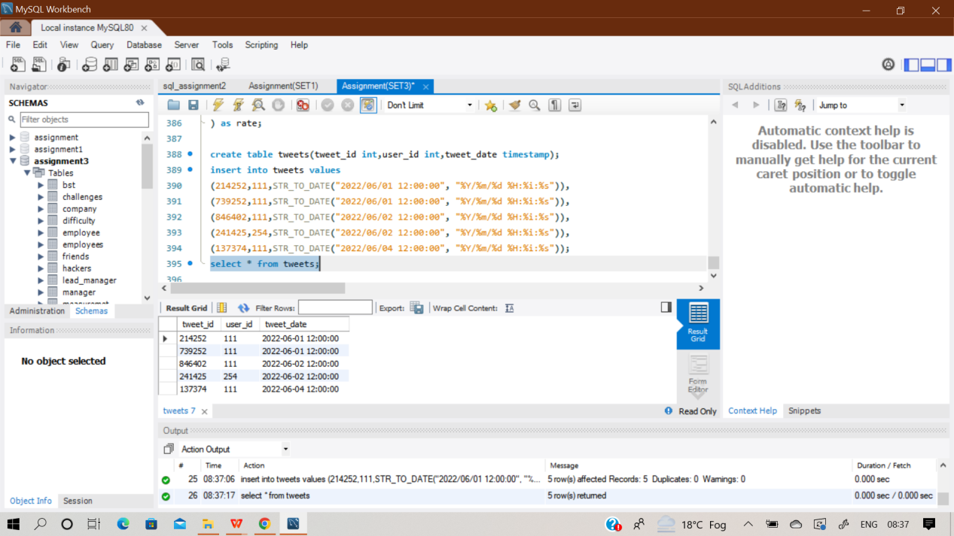

**select user_id, tweet_date,**

**round( avg(tweet_num) over (partition by user_id**

**order by user_id,**

**tweet_date rows between 2 preceding and current row), 2) as rolling_avg_3d**

**from ( select user_id, tweet_date,**

**count(distinct tweet_id) as tweet_num**

**from tweets**

**group by user_id, tweet_date) as tweet_count;**

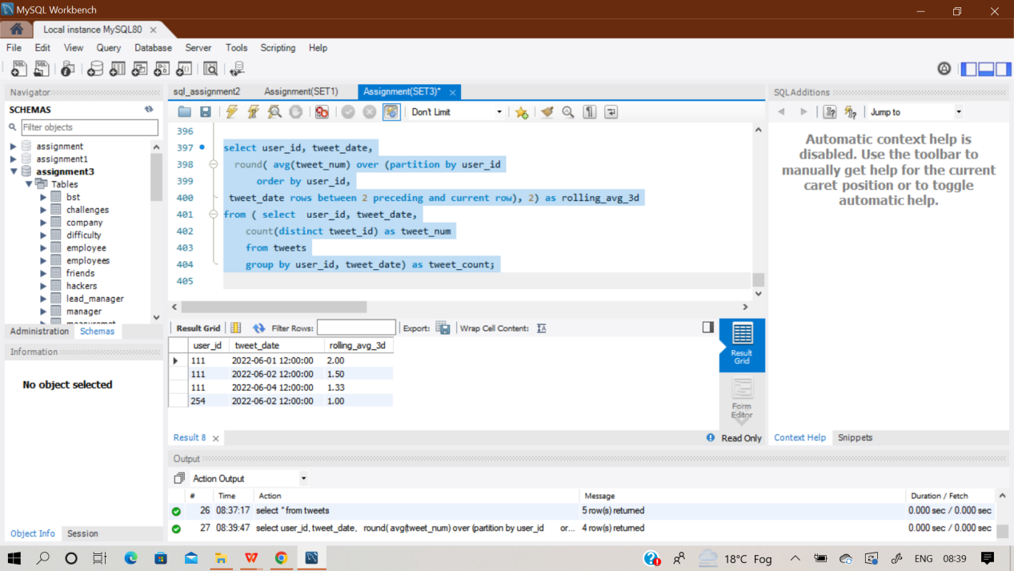

**Q171) Assume you are given the tables below containing information on Snapchat users, their ages, and their time spent sending and opening snaps. Write a query to obtain a breakdown of the time spent sending vs. opening snaps (as a percentage of total time spent on these activities) for each age group.**

**Hint- Use join and case Output the age bucket and percentage of sending and opening snaps. Round the percentage to 2**

**decimal places.**

Sol) At first create 2 empty tables ‘Activities ’ & ’Age_breakdown’ and insert values in it.

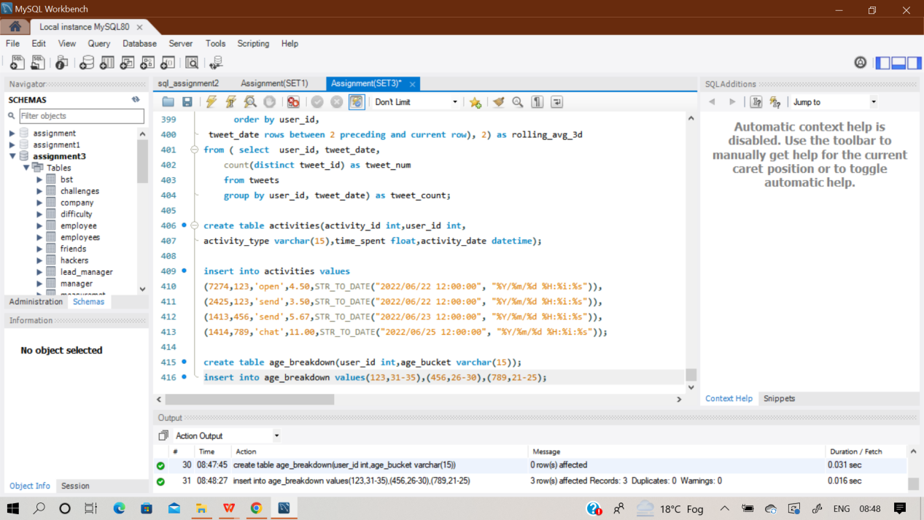

**with snaps_statistics as (select age.age_bucket,**

**sum(case when activities.activity_type = 'send'**

**then activities.time_spent else 0 end) as send_timespent,**

**sum(case when activities.activity_type = 'open'**

**then activities.time_spent else 0 end) as open_timespent,**

**sum(activities.time_spent) as total_timespent**

**from activities**

**inner join age_breakdown as age**

**on activities.user_id = age.user_id**

**where activities.activity_type in ('send', 'open')**

**group by age.age_bucket)**

**select age_bucket,**

**round(100.0*send_timespent/total_timespent,2)as send_perc,**

**round(100.0 * open_timespent / total_timespent, 2) as open_perc**

**from snaps_statistics;**

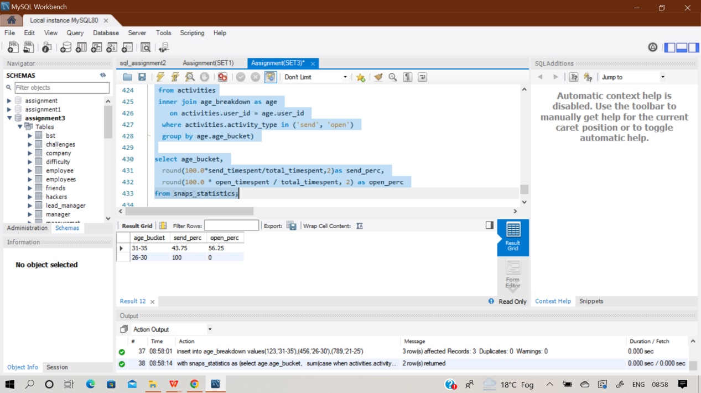

**Q172) The LinkedIn Creator team is looking for power creators who use their personal profile as a company or influencer page. This means that if someone's Linkedin page has more followers than all the companies they work for, we can safely assume that person is a Power Creator. Keep in mind that if a person works at multiple companies, we should take into account the company with the most**

**followers.**

**Write a query to return the IDs of these LinkedIn power creators in ascending order**

Sol) At first create 3 empty tables ‘personal_profile’,‘employee_company’ & ‘company_pages’ and insert values in it using multi insert command.

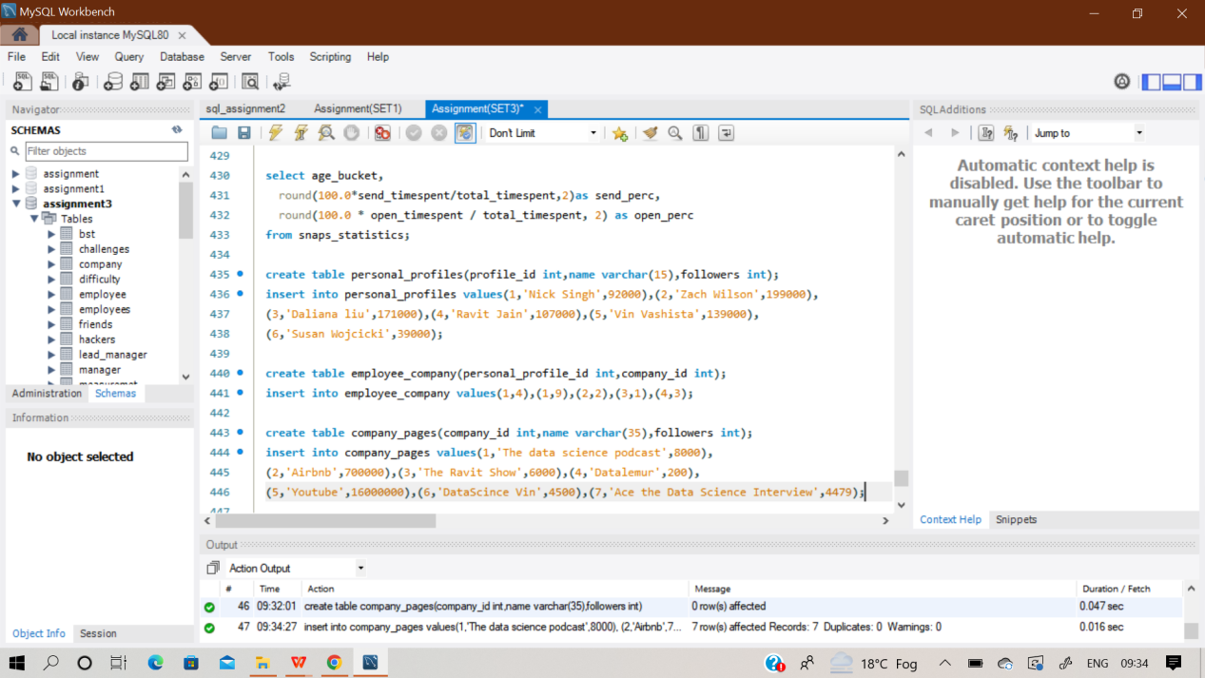

**select distinct p.profile_id from personal_profiles p inner join employee_company e**

**on p.profile_id=e.personal_profile_id inner join company_pages c**

**on e.company_id=c.company_id**

**where p.followers>c.followers and p.profile_id not in**

**( select p.profile_id from personal_profiles p inner join employee_company e**

**on p.profile_id=e.personal_profile_id**

**inner join company_pages c on e.company_id=c.company_id**

**where p.followers<c.followers)**

**order by p.profile_id;**

